**Title: - Hybrid Workforce Management System Using CRM - Salesforce**

**Project Overview:** The Hybrid Workforce Management System (HWMS) is a Salesforce-based CRM solution designed to empower organizations to manage and optimize their hybrid work culture—where employees alternate between onsite, remote, or flexible work modes. The system centralizes employee scheduling, attendance, productivity tracking, and feedback management in one integrated platform.

Built using Salesforce Experience Cloud, Apex, Flows, and Lightning Web Components (LWC), the application provides real-time visibility into employee activities, compliance with hybrid work policies, and overall workforce wellbeing. It automates the management of work schedules, captures productivity metrics, and facilitates transparent communication between employees and managers.

The portal enhances workforce efficiency and engagement by enabling employees to log attendance, request hybrid work days, submit feedback, and view their performance trends—all from a personalized dashboard. HR and management teams can monitor attendance, productivity, and policy compliance through automated reports and dashboards.

By combining automation, real-time analytics, and secure access control, the Hybrid Workforce Management System helps organizations maintain transparency, ensure policy adherence, and build a data-driven hybrid work culture that supports both flexibility and accountability.

**Objectives:**

* Centralized Workforce Management: Provide a single platform to manage hybrid employee schedules, attendance, and productivity data.
* Automation of Workflows: Streamline hybrid work scheduling, feedback collection, and policy compliance tracking using Flows and Apex.
* Employee Empowerment: Enable employees to log work modes, track productivity, and submit wellbeing feedback through a self-service interface.
* Real-Time Insights: Equip HR and management with actionable dashboards for attendance, compliance, and engagement analysis.
* Policy Compliance Monitoring: Automatically track and alert managers about violations of hybrid work policies using Scheduled Apex and Flows.
* Secure & Role-Based Access: Ensure data privacy through Salesforce profiles, permission sets, and Experience Cloud login-based visibility.

**Student Outcomes:**

* Hands-On Salesforce Development: Gain practical experience in building a workforce management solution using Apex, Flows, and LWC.
* End-to-End Application Design: Learn to design and integrate data models, automation, and UI for a hybrid work management system.
* Automation Expertise: Implement real-time process automation for scheduling, attendance, and compliance tracking.
* Experience Cloud Implementation: Understand how to build an employee-facing portal for hybrid workforce operations.
* Analytical Thinking: Create reports and dashboards for HR insights, reinforcing data-driven decision-making.
* Asynchronous Apex Skills: Learn to use Queueable or Scheduled Apex for large-scale compliance calculations and performance updates.

**System Requirements:**

**Hardware Requirements:**

* Computer with minimum 4 GB RAM, Dual-core processor
* Stable internet connection

**Software Requirements**:

* Salesforce Developer Edition Org
* Modern Web Browser (e.g., Google Chrome, Firefox)

**Skills Required:**

* Salesforce Configuration and Data Modeling
* Security and Access Management
* Apex Triggers, Classes, and Asynchronous Apex (Queueable, Scheduled)
* Flow Builder (Record-Triggered & Scheduled Flows)
* Lightning Web Components (LWC) Development
* Experience Cloud Site Configuration
* Reports and Dashboard Creation

**Phases Overview:**

|  |  |  |  |
| --- | --- | --- | --- |
| **Phase No.** | **Phase Name** | **Description** | **Page Numbers** |
| 1 | Requirement Analysis & Planning | Define business goals, gather requirements, and plan the architecture. | 5 - 8 |
| 2 | Salesforce Development - Backend & Configurations | Set up objects, fields, automation, and Apex logic. | 9 - 53 |
| 3 | UI/UX Development & Customization | Design intuitive interfaces using Lightning Components and Flows. | 53 - 72 |
| 4 | Data Migration, Testing & Security | Migrate data, test functionality, and enforce data security. | 72- 80 |
| 5 | Deployment, Documentation & Maintenance | Deploy the solution, train users, maintain system health, resolve issues, Documentation. | 80- 86 |

**Project Main Overview:**

The Hybrid Workforce Management System (HWMS) is a Salesforce-powered Experience Cloud application that streamlines hybrid work operations across departments. It is designed to handle the complexities of managing employees who alternate between remote, onsite, or flexible schedules.

The system’s data model consists of key objects such as *Work_Schedule__c, Employee_Feedback__c, Productivity_Log__c,* and *Policy_Compliance__c*. These objects store and interlink information about employee schedules, productivity, feedback, and compliance. Using Flows and Apex Triggers, the system automates tasks like assigning work modes, validating daily attendance, and sending alerts for policy violations.

Employees interact through LWC components embedded in an Experience Site, allowing them to check in daily, submit feedback, and view performance insights. HR managers and supervisors can monitor all activity from dashboards and reports that present real-time data on attendance, productivity, and engagement.

The system also includes approval processes for remote work requests and validation rules to ensure data accuracy (e.g., preventing duplicate attendance records). Email templates are used to send notifications about approvals, compliance issues, and low wellbeing scores.

Ultimately, the Hybrid Workforce Management System enhances organizational productivity and employee satisfaction by creating a flexible yet accountable hybrid work environment powered entirely by Salesforce.

**Main Objectives**

The primary goal of the **Hybrid Workforce Management System** is to establish an automated, transparent, and secure framework for managing employees in a hybrid work environment.

* **Automated Work Mode Management:** Enable employees to check in and record their work mode (Onsite, Remote, Hybrid) through Flows and LWCs.
* **Productivity Tracking:** Capture daily productivity metrics using Apex logic and summarize them in dashboards.
* **Feedback and Wellbeing Monitoring:** Collect and evaluate employee feedback using Flows and triggers to promote engagement.
* **Policy Compliance:** Use Scheduled Apex to automatically verify adherence to hybrid policies (e.g., required onsite days per week).
* **Approval Process for Remote Requests:** Automate multi-step approvals for extended remote work using Salesforce’s approval process feature.
* **Real-Time Dashboards:** Provide HR and management with visual insights into attendance, feedback trends, and compliance rates.
* **Data Security and Access Control:** Enforce field-level and role-based visibility using profiles, permission sets, and Experience Cloud login rules.
* **Email Notifications:** Notify employees and managers automatically about feedback responses, approvals, and compliance alerts.

# **Phase 1: Requirement Analysis & Planning**

1. **Understanding Business Requirements**

**Objective:**

Understand how organizations manage hybrid work environments—where employees alternate between onsite, remote, or flexible work modes—and identify challenges in maintaining productivity, engagement, wellbeing, and compliance. The goal is to build a Salesforce-based solution that provides centralized visibility, automation, and analytics for managing a distributed workforce efficiently.

**Approach**:

* Gather and analyze requirements from HR managers, department heads, employees, and IT administrators to understand hybrid work practices and operational pain points.
* Study how employee attendance, work modes, and productivity are currently tracked, and how HR monitors compliance with hybrid work policies.
* Identify challenges such as lack of real-time attendance visibility, manual compliance tracking, no structured feedback collection, and limited data-driven insights.
* Conduct requirement study using multiple sources such as ChatGPT, Google, Salesforce Documentation, and Trailhead, to design a scalable and secure **Hybrid Workforce Management System** on the Salesforce platform.

**Key Business Requirements Identified**:

* Provide a Salesforce-based application for managing employee hybrid work schedules and attendance.
* Automate hybrid work tracking, productivity evaluation, and policy compliance using Apex and Flows.
* Enable employees to log their daily work mode (Remote, Onsite, Hybrid) through a self-service portal.
* Allow managers and HR teams to monitor attendance, productivity, and compliance through dashboards.
* Collect and analyze employee feedback to measure engagement and wellbeing.
* Ensure secure, role-based visibility for employees, managers, and HR personnel.
* Generate analytical dashboards and reports for HR to monitor hybrid workforce performance and policy adherence.

1. **Defining Project Scope & Objectives**

**Project Scope:**

* Build a **Salesforce-based Hybrid Workforce Management System** that automates hybrid work scheduling, attendance tracking, feedback collection, and compliance management.
* Integrate automation (Flows, Apex), UI (LWC), and analytics (Reports & Dashboards) for real-time insights.
* Provide self-service capabilities for employees to log attendance and submit feedback via an Experience Cloud site.
* Implement role-based access controls and security measures to protect employee data.
* Enable HR managers to configure hybrid policies and monitor workforce performance trends.

**Objectives Summary**:

* Simplify hybrid work operations through automation of scheduling, attendance, and compliance workflows.
* Empower employees with a self-service platform for work mode logging and feedback submission.
* Enhance visibility and accountability through real-time dashboards for managers and HR.
* Improve workforce engagement and wellbeing tracking using custom objects and flows.
* Ensure secure access and data privacy through profile-based and login-based visibility settings.
* Support data-driven decision-making through analytics and productivity reports.

1. **Gathering & Analyzing User Needs**

**Users Involved:**

* **Employees:** Log daily work mode, view schedules, submit feedback, and check productivity trends.
* **Managers:** Monitor team attendance, approve hybrid work requests, and track productivity performance.
* **HR Team:** Manage hybrid policies, monitor compliance, and review wellbeing analytics.
* **System Administrator:** Configure user access, maintain security, and oversee automation processes.

**Key Functional Needs**:

* Intuitive employee dashboard with check-in/check-out capabilities.
* Ability for employees to select their daily work mode (Remote, Onsite, Hybrid).
* Feedback form for submitting wellbeing or engagement ratings.
* Manager dashboards for attendance, productivity, and policy compliance.
* Automated compliance validation for required onsite days using Flows or Scheduled Apex.
* Email alerts for low feedback ratings, policy violations, and manager notifications.
* Analytical dashboards to track workforce distribution, performance, and wellbeing trends.

**Tools Used:**

* **Google Forms**: To collect business and user requirements from HR and managers.
* **Miro Boards:** To visualize employee work mode workflows and compliance processes.
* **User Personas:** To tailor experiences for employees, managers, and HR teams.

**Note:** The tools used are mentioned considering real-time project implementation practices.

1. **Identifying Key Salesforce Features & Tools Required**

**Salesforce Features Planned:**

* **Custom Objects:**
  + Work_Schedule__c → Stores daily attendance, work mode, and shift timings.
  + Productivity_Log__c → Tracks daily productivity and completed tasks.
  + Employee_Feedback__c → Captures wellbeing ratings and engagement comments.
  + Policy_Compliance__c → Tracks hybrid work policy adherence.
* **Standard Object:**
  + User → Represents employees, managers, and HR users.
* **Automations:**
  + Record-Triggered Flows, Approval Processes, and Scheduled Flows for policy checks.
* **Apex:**
  + Triggers for validation, asynchronous classes for compliance calculations, and Apex controllers for LWC.
* **UI:**
  + Lightning App Pages, Dynamic Forms, and Lightning Web Components for dashboards and feedback submission.
* **Email Services:**
  + Email Templates and Alerts for approvals, compliance notifications, and wellbeing alerts.
* **Security:**
  + Profiles, Permission Sets, Role Hierarchy, Field-Level Security, and Login-Based Component Visibility.

1. **Designing Data Model and Security Model**

**Data Model Includes:**

**Work_Schedule__c (Custom Object)**

1. Stores employee attendance and work mode (Remote, Onsite, Hybrid).
2. Linked to *User* for employee identification.
3. Includes fields like Date, Location, Shift, and Status.

**Productivity_Log__c (Custom Object)**

1. Records daily productivity data, such as completed tasks and performance score.
2. Linked to *User* for tracking employee productivity.
3. Used for weekly productivity reports and dashboards.

**Employee_Feedback__c (Custom Object)**

1. Captures feedback related to workload, engagement, and wellbeing.
2. Contains fields like Rating (1–5), Comments, and Category.
3. Triggers email alerts for low ratings (≤2).

**Policy_Compliance__c (Custom Object)**

1. Monitors hybrid work policy compliance based on required vs. actual onsite days.
2. Automatically updated via Scheduled Apex or Flow.

**User (Standard Object)**

1. Represents employees, managers, and HR personnel.
2. Used for role-based access, ownership, and lookups.

**Security Model Design**:

* **Role Hierarchy:** Admin → HR Manager → Manager → Employee.
* **Profiles:** System Administrator, HR User, Manager User, Employee User.
* **Record-Level Security:** Implemented using Sharing Rules and Owner-based Access.
* **Field-Level Security:** Protects sensitive information such as employee details and ratings.
* **Component Visibility:** Managed in Experience Builder using login-based component visibility for dashboards and forms.

**Summary:**

# This phase established a comprehensive understanding of hybrid workforce management needs, challenges, and goals. Through detailed requirement analysis and user mapping, a clear project scope and feature set were defined. The data model and security framework were designed to ensure scalability, automation readiness, and compliance with organizational data privacy standards.

# **Phase 2: Salesforce Development –Backend & Configurations**

The Backend & Configuration phase established the functional foundation of the Hybrid Workforce Management System.  
This phase focused on configuring data models, creating automation through Flows and Apex, and ensuring secure handling of employee scheduling, work mode tracking, and productivity reporting.

Using Salesforce declarative tools (Flows, Approval Processes, Validation Rules) alongside programmatic logic (Apex Classes, Triggers, and Async Apex), the system enables seamless coordination between remote, on-site, and hybrid employees while maintaining visibility and compliance for HR and managers.

## **Milestone 1: Salesforce Account**

**Introduction:**

Are you new to Salesforce? Not sure exactly what it is, or how to use it? Don’t know where you should start on your learning journey? If you’ve answered yes to any of these questions, then you’re in the right place. This module is for you.

Welcome to Salesforce! Salesforce is game-changing technology, with a host of productivity-boosting features, that will help you sell smarter and faster. As you work toward your badge for this module, we’ll take you through these features and answer the question, “What is Salesforce, anyway?”.

**What Is Salesforce?**

Salesforce is your customer success platform, designed to help you sell, service, market, analyze, and connect with your customers.

### **Activity 1: Creating Developer Account:**

Creating a developer org in salesforce.

1. Go to <https://developer.salesforce.com/signup>
2. On the sign-up form, enter the following details:

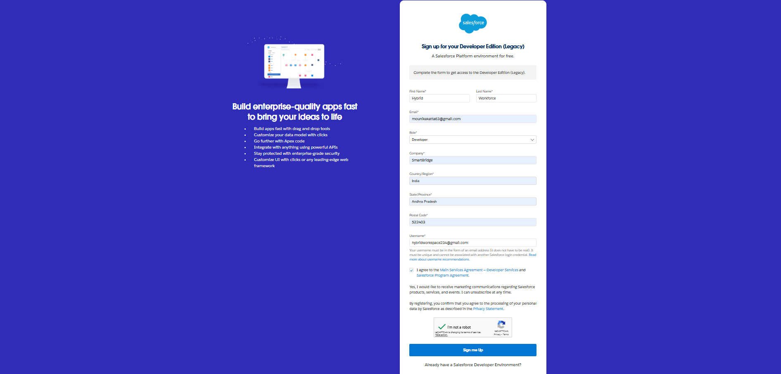

1. First name & Last name
2. Email
3. Job Title: Developer
4. Company: College Name
5. Country: India

Click on sign me up after filling these.

### **Activity 2: Account Activation**

1. Go to the inbox of the email that you used while signing up. Click on the verify account to activate your account. The email may take 10-30mins and sometimes 2 hours.

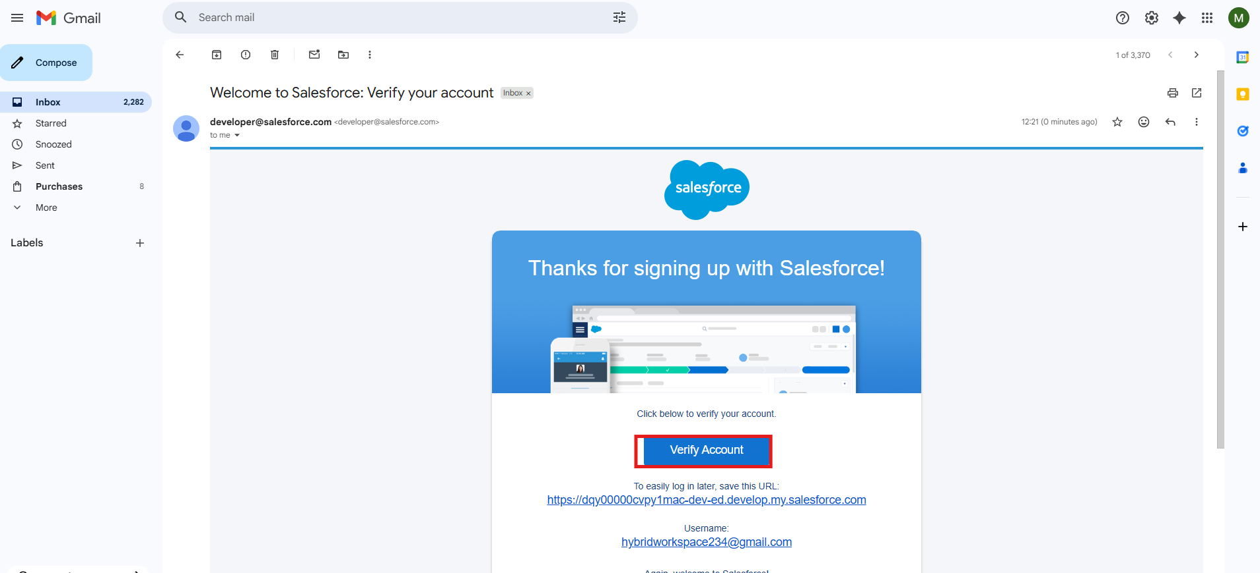

1. Click on Verify Account
2. Give a password and answer a security question and click on change password.

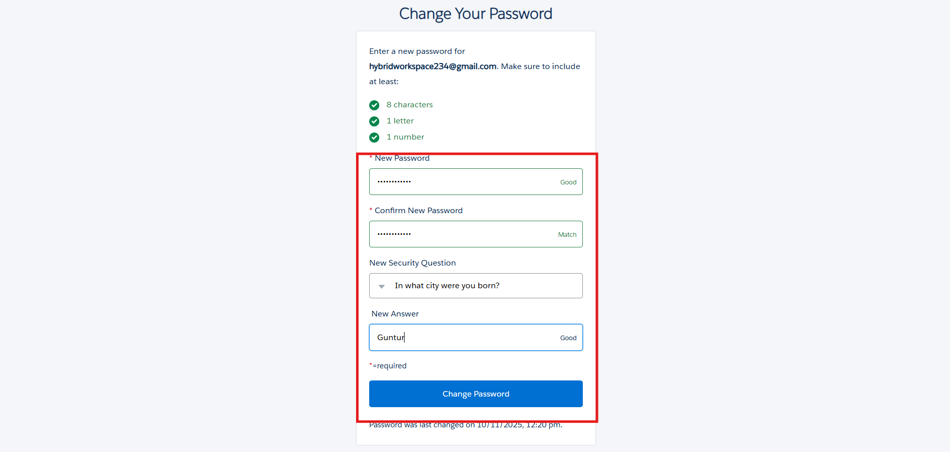

1. Then you will redirect to your salesforce setup page.

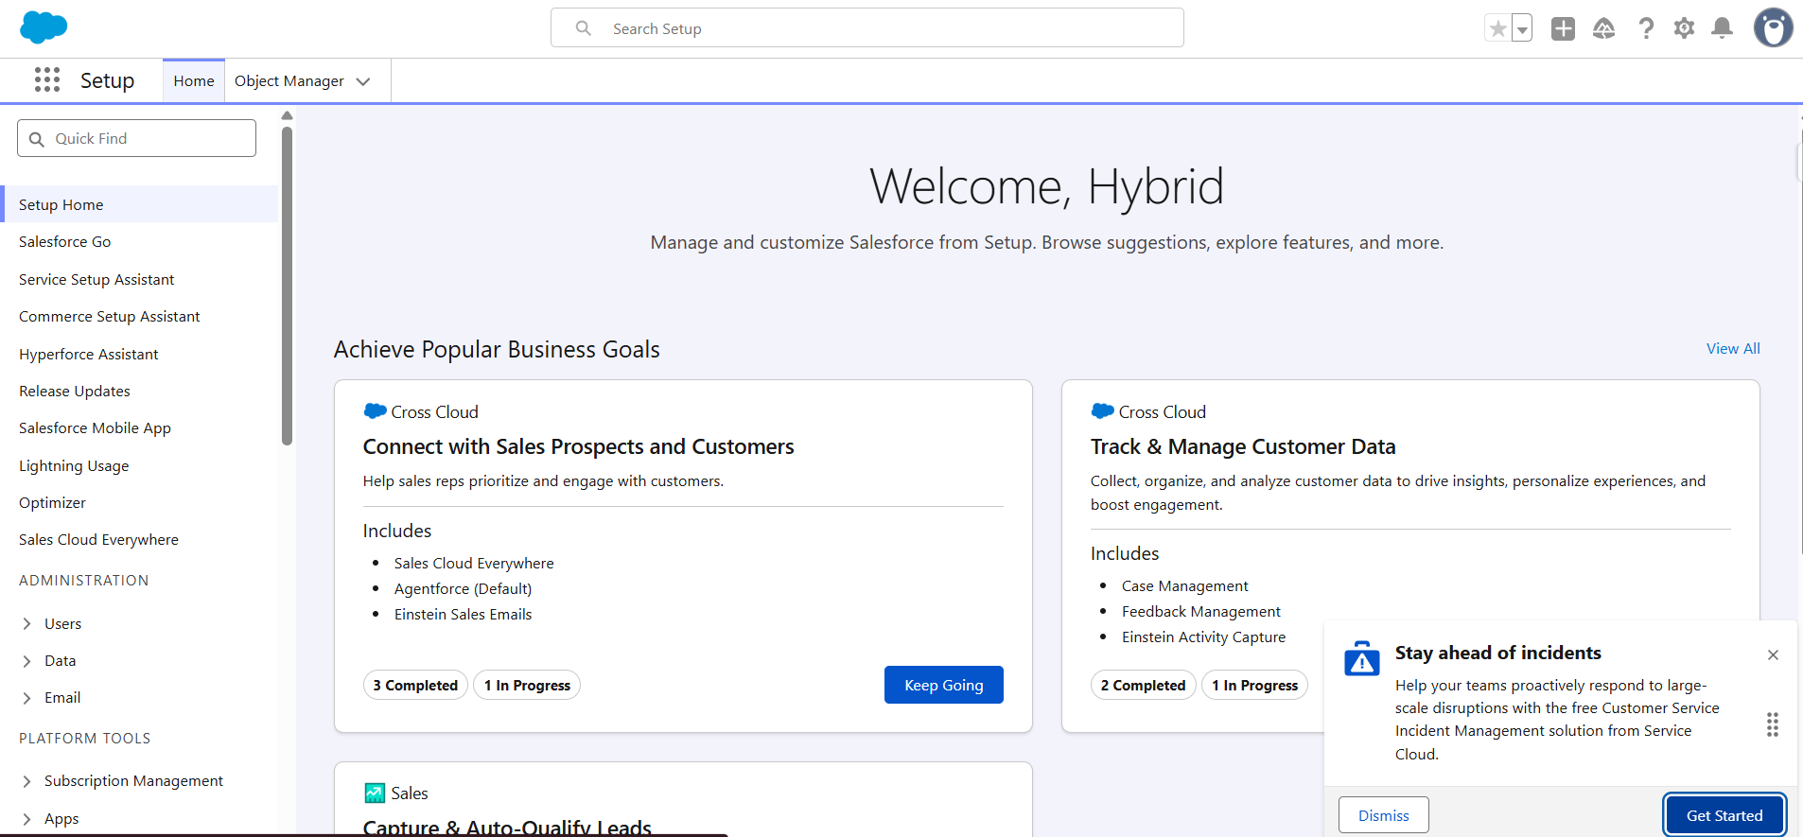

# 

## **Milestone 2: Objects Creation**

### **Activity 1: Creating a Work Schedule Object**

To create an object:

1. From the setup page
2. Click on Object Manager
3. Click on Create >> Click on Custom Object.
4. Enter the label name as Work Schedule
5. Enter Plural label name as Work Schedules
6. Enter Record Name as Schedule Id
7. Select Data Type as Auto Number: {0000}, Starting with ‘1’.
8. Select Allow reports.
9. Select Allow search**.**
10. Allow Track Field History
11. Click on Save and New

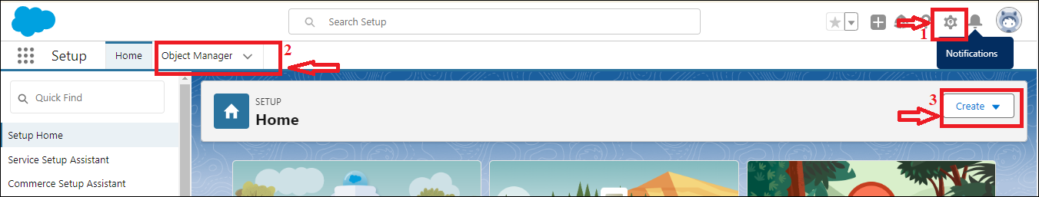

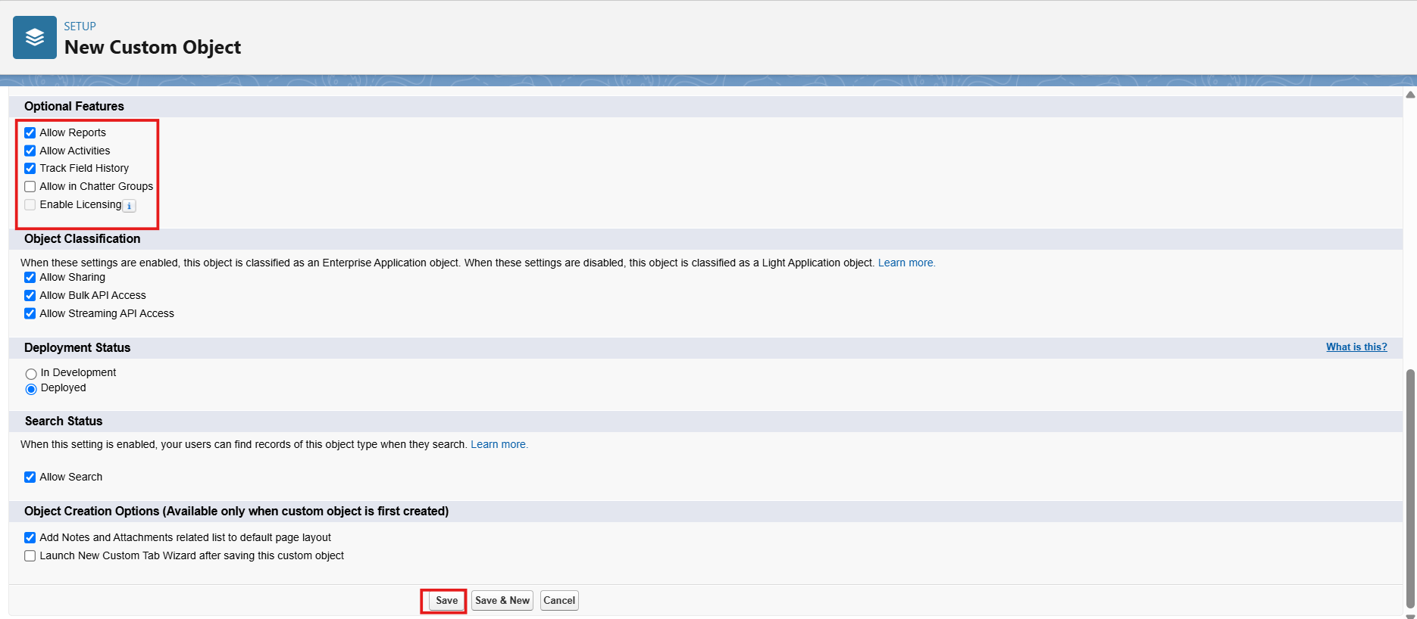

### **Activity 2: Creating a Attendance Log Object**

To create an object:

1. From the setup page
2. Click on Object Manager
3. Click on Create >> Click on Custom Object.
4. Enter the label name as Attendance Log
5. Enter Plural label name as Attendance Logs
6. Enter Record Name as Attendance Id
7. Select Data Type as Auto Number: {0000}, Starting with ‘1’.
8. Select Allow reports.
9. Select Allow search**.**
10. Allow Track Field History
11. Click on Save and New

### **Activity 3: Creating a Wellbeing Feedback Object**

To create an object:

1. From the setup page
2. Click on Object Manager
3. Click on Create >> Click on Custom Object.
4. Enter the label name as Wellbeing Feedback
5. Enter Plural label name as Wellbeing Feedback
6. Enter Record Name as Feedback Id
7. Select Data Type as Auto Number: {0000}, Starting with 1.
8. Select Allow reports.
9. Select Allow search**.**
10. Allow Track Field History
11. Click on Save and New

### **Activity 4: Creating an Hybrid Policy Object**

To create an object:

1. From the setup page
2. Click on Object Manager
3. Click on Create >> Click on Custom Object.
4. Enter the label name as Hybrid Policy
5. Enter Plural label name as Hybrid Policies
6. Enter Record Name as Policy Name
7. Select Data Type as Text: Policy Name.
8. Select Allow reports.
9. Select Allow search**.**
10. Allow Track Field History
11. Click on Save and New

### **Activity 5: Creating an Announcement Object**

To create an object:

1. From the setup page
2. Click on Object Manager
3. Click on Create >> Click on Custom Object.
4. Enter the label name as Announcement
5. Enter Plural label name as Announcements
6. Enter Record Name as Announcement Title
7. Select Data Type as Text: Announcement Title.
8. Select Allow reports.
9. Select Allow search**.**
10. Allow Track Field History

Click on Save and New

### **Activity 6: Creating a Task Assignment Object**

To create an object:

1. From the setup page
2. Click on Object Manager
3. Click on Create >> Click on Custom Object.
4. Enter the label name as Task Assignment
5. Enter Plural label name as Task Assignments
6. Enter Record Name as Task Id
7. Select Data Type as Auto Number: {0000}, Starting with ‘1’.
8. Select Allow reports.
9. Select Allow search**.**
10. Allow Track Field History

Click on Save and New

## **Milestone 3- Tabs**

### **Activity 1: Creating a tab for Work Schedule Object**

1. Go to the setup page → type Tabs in Quick Find bar
2. Click on tabs
3. Click on New (under custom object tab).
4. Select Object (Work Schedule) >> Select the tab style
5. Click on Next >> (Add to profiles page) keep it as default >> Click on Next (Add to Custom App) uncheck the include tab.
6. Make sure that the Append tab to the user's existing personal customizations is checked.
7. Click save
8. Create tabs for every object created in milestone-2.

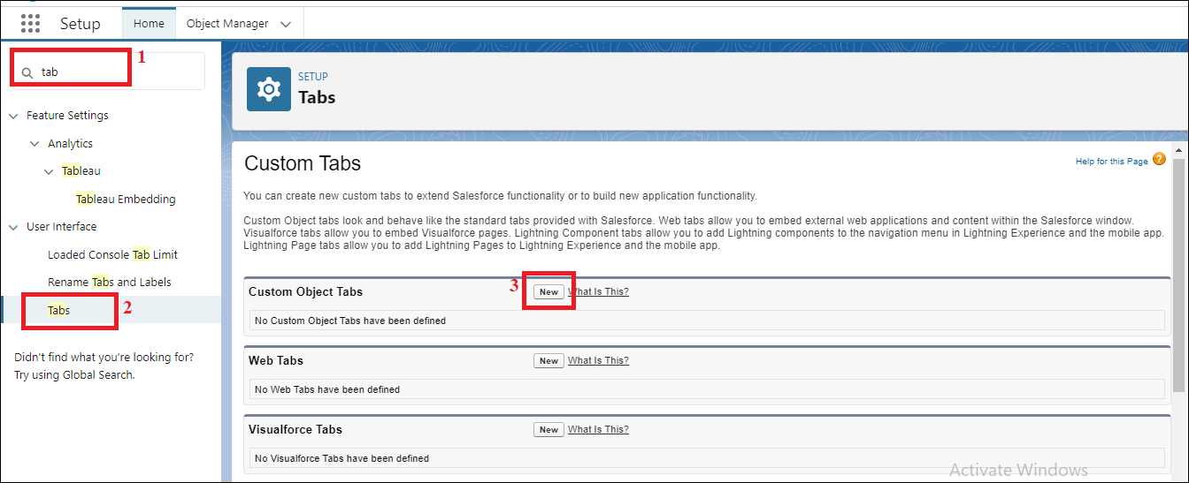

## **Milestone 4: Fields & Relationships**

|  |  |  |  |
| --- | --- | --- | --- |
| **Object** | **Field Name** | **Data Type** | **Required** |
| **Work_Schedule__c** | Schedule ID | Auto Number | Yes |
|  | Employee | |  | | --- | | Lookup(Contact) |  |  | | --- | |  | | Yes |
|  | |  | | --- | | Work Mode |  |  | | --- | |  | | |  | | --- | |  |   Picklist(Remote, Office, Hybrid |  |
|  | |  | | --- | | Start Date |  |  | | --- | |  | | Date | Yes |
|  | End Date | Date | Yes |
|  | Manager | Lookup to User |  |
| **Attendance_Log__c** | Attendance ID | Auto Number | Yes |
|  | Employee | Lookup to contact | Yes |
|  | Check-in Time | Date/time | Yes |
|  | Check-out Time | Date/time | Yes |
|  | Work Mode | Picklist (Remote, Office) | Yes |
| **Wellbeing_Feedback__c** | Feedback Id | Auto Number: {0000}, Starting number is 1. | Yes |
|  | Employee | Lookup to Contact | Yes |
|  | Feedback Date | Date |  |
|  | Rating | Picklist (1–5) | Yes |
|  | Comments | Long Text Area |  |
| **Hybrid_Policy__c (Custom Object)** | Policy Name (Standard) | Text | Yes |
|  | Category | Picklist (HR, IT, POSH, Compliance, General) | Yes |
|  | Description | Long Text Area | Yes |
| **Announcements (Custom Object)** | Announcement Title (Standard) | Text | Yes |
|  | Audience | Picklist (HR, IT, Salesforce, ServiceNow, App Development, SRS, All) | Yes |
|  | Description | Long Text Area |  |
|  | End Date | Date |  |
|  | Start Date | Date |  |
| |  | | --- | | **Task_Assignment__c** |  |  | | --- | |  | | Task ID | Auto Number | Yes |
|  | Employee | Lookup to Contact | Yes |
|  | Task Title | Text | Yes |
|  | Priority | Picklist (Low, Medium, High) | Yes |
|  | Status | Picklist (Open, In Progress, Completed) | Yes |

### **Activity 1: Creation of Picklist field for the work Schedule object:**

**Create Picklist Field in a work schedule object**:

1. Go to setup >> click on Object Manager >> type object name (work schedule) in quick find box>> click on the work schedule Object.
2. Now click on “Fields & Relationships”.
3. Click on New.
4. Select Data type as “Picklist” and click Next.
5. Enter the Field Label as “Work Mode”.
6. Click on Enter values and Enter Remote, Office, Hybrid.
7. Click on Next, Next and Save.

### **Activity 2: Creation of Lookup field for the Work Schedule Object:**

**1.Creating Lookup Relationship in Work Schedule Object**

1. Go to the Setup page >> click on Object manager >> type object name (Work Schedule) in the quick find bar >> click on the Work Schedule object.

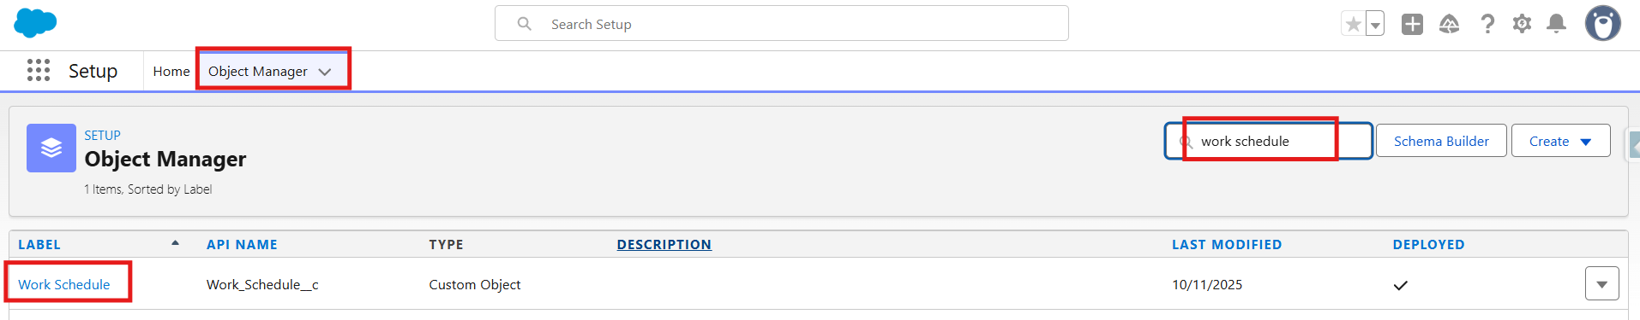

1. Click on Fields & Relationship
2. Click on New.

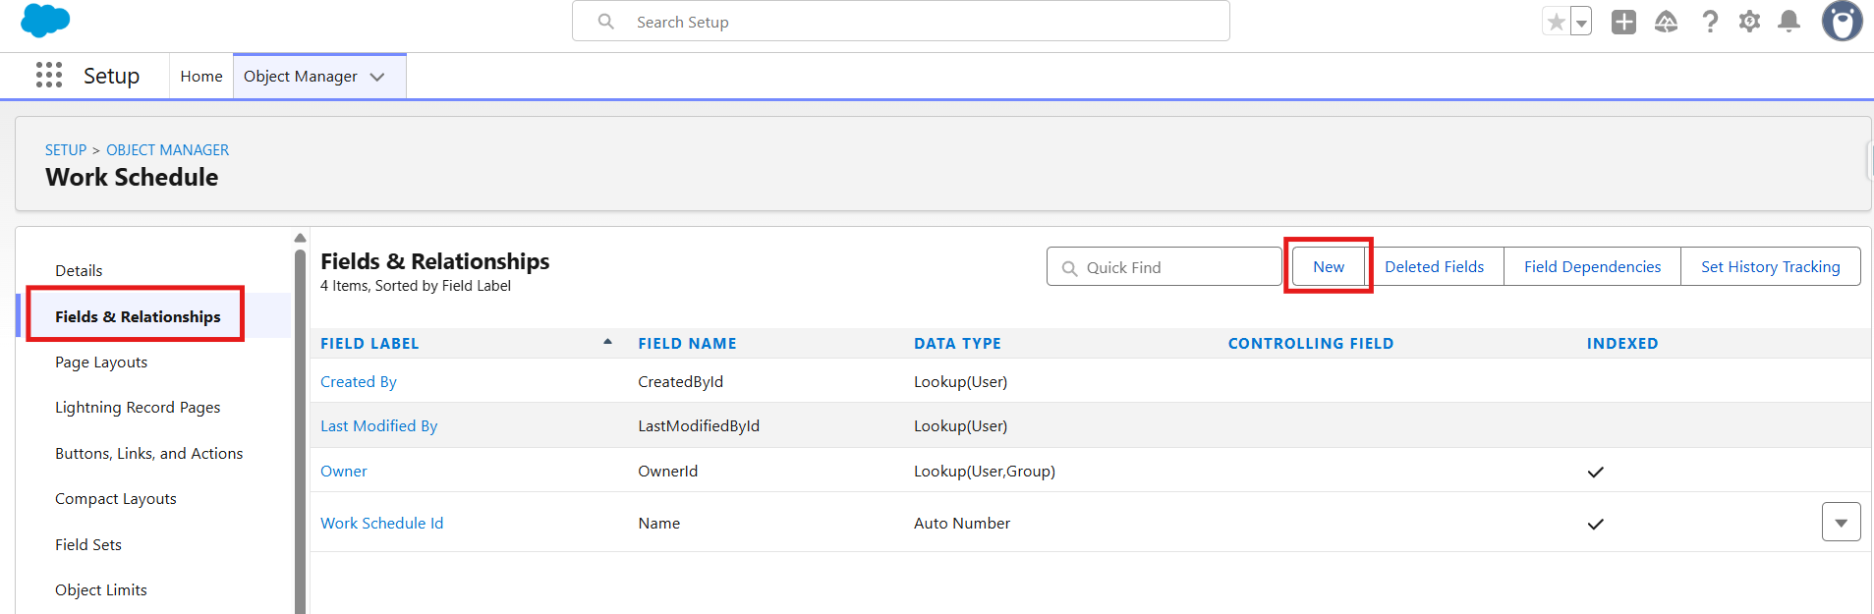

1. Select “Lookup relationship” as data type and click Next.

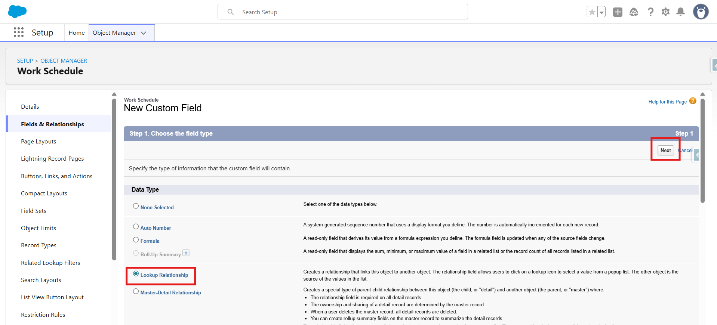

1. Select the related object “Employee”.

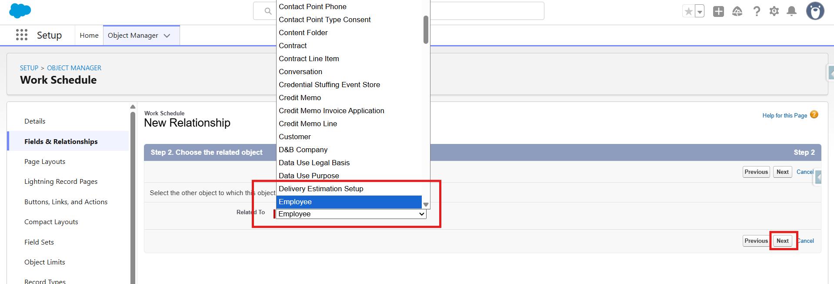

1. Click on Next.
2. Give Field Label as “Employee”.
3. Click on Next, Next, Next, Save.

**Note:** Create other fields from the above Fields table related to this object and choose the data types of the fields carefully.

## **Milestone 5 - Validation Rules**

### **Activity 1: To create a Validation rule to an Attendance Log Object**

**1.Validation Rule on check-in and check-out:**

1. Go to setup >> click on Object Manager >> type object name (Attendance Log) in search bar >> click on the Attendance Log object
2. Click on the validation rule >> click on New.

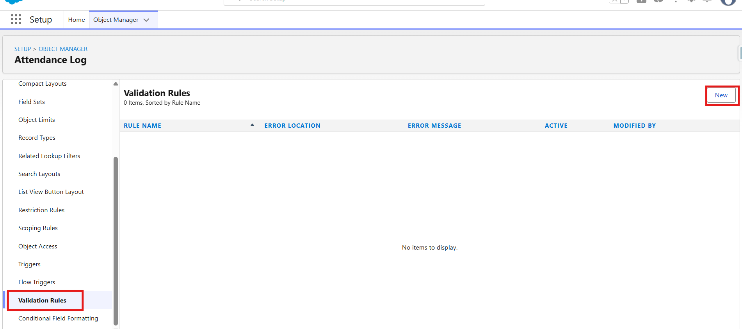

1. Enter the Rule name as “Check-out After Check-in”.
2. Select Active
3. Insert the Error Condition Formula as: Check_Out_Time__c < Check_In_Time__c 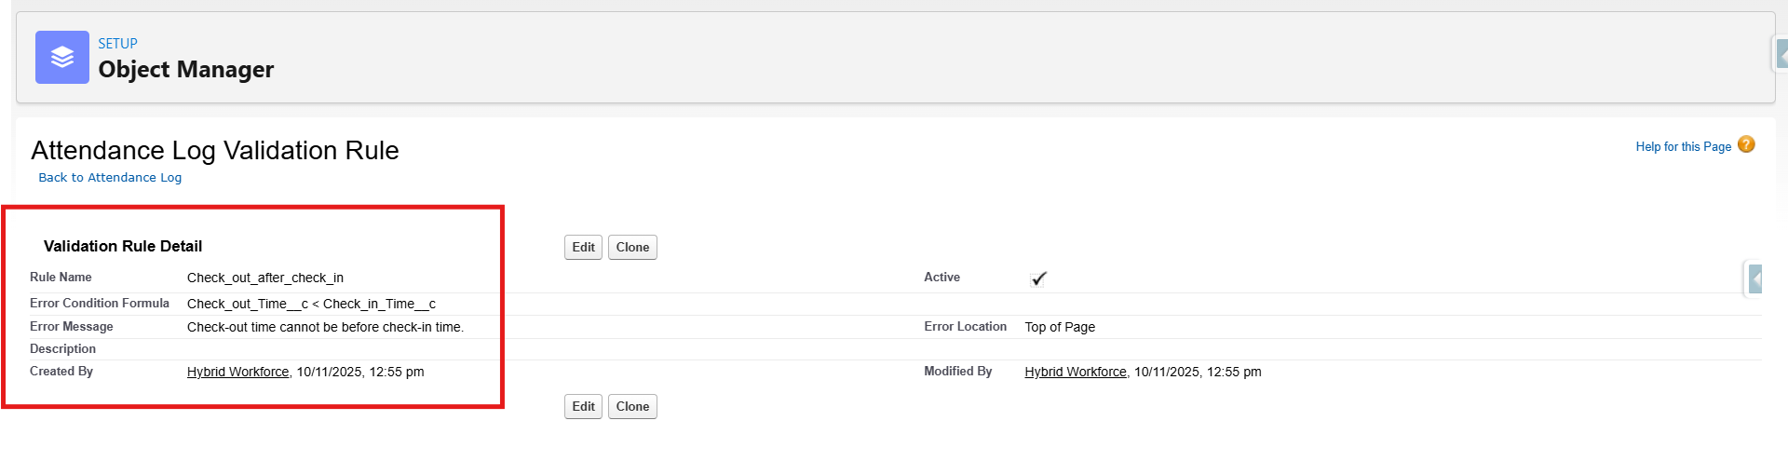
4. Enter the Error Message as “Check-out time cannot be before check-in time.”.
5. Select the Error location as Top of the page
6. Click Save.

### **Activity 2: To create a Validation rule to an Work Schedule Object**

**1.Validation Rule on valid date range:**

1. Go to setup >> click on Object Manager >> type object name (Work Schedule) in search bar >> click on the Work Schedule object
2. Click on the validation rule >> click on New.
3. Enter the Rule name as “Check valid date range”.
4. Select Active
5. Insert the Error Condition Formula as: End_Date__c < Start_Date__c.
6. Enter the Error Message as “End Date must be after Start Date.”.
7. Select the Error location as Top of the page
8. Click Save.

## **Milestone 6: APPROVAL PROCESS**

### **Activity 1: Create an Approval Process for Work Schedule Approval**

**Note:** Before Implementing Approval Process First Complete Profiles, Roles and Users Milestones.

**1.Create Classic Email Template**

* Go to Setup (gear icon on top-right)
* In the Quick Find box, type: Email Templates
* Click on Classic Email Templates
* Click "New Template"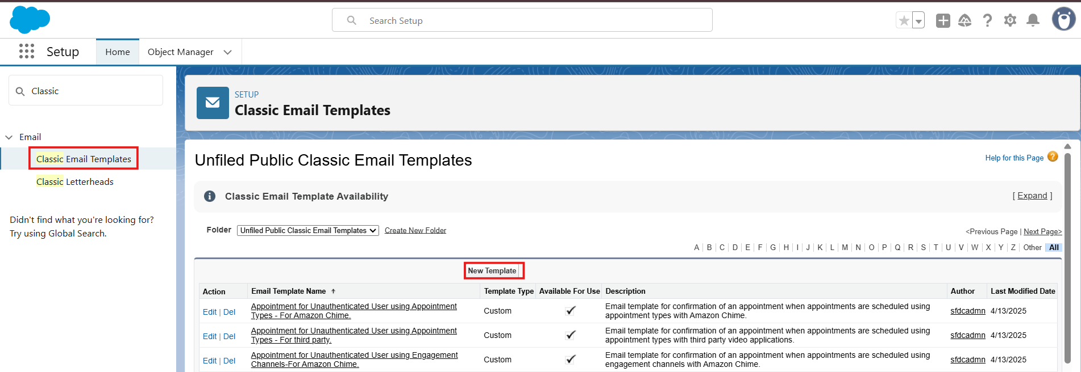
  + You’ll now choose the type of email template you want to create.

Choose the type:

* Text – Plain text (no formatting)
* Click Next

Email Template Information:

|  |  |
| --- | --- |
| Folder | Public or private folder (use "Unfiled Public Email Templates" for now) |
| Email Template Name | Work Schedule Approval Notification to Approvers. |
| Template Unique Name | Auto-filled, or change it (no spaces) |
| Encoding | Leave default (UTF-8) |
| Subject | New work schedule request for an approval! |
| Email Body | Dear {!Work_Schedule__c.Approver__c},  A new work schedule request has been submitted and is awaiting your approval. Please review the details below:  **Request Details:**  - Submitted By: {!Work_Schedule__c.Employee__c}  - Submission Date: {!Work_Schedule__c.CreatedDate}  - Start Date: {!Work_Schedule__c.Start_Date__c}  - End Date: {!Work_Schedule__c.End_Date__c}  - Shift Type: {!Work_Schedule__c.Shift_Type__c}  - Reason / Notes: {!Work_Schedule__c.Reason__c}  If you have any questions or need additional information, please contact the requester directly.  Thank you for your prompt attention.  Best regards,  The Hybrid Workforce Team |

**2. Create the Approval Process**

* In the Quick Find box, type: Approval Processes
* Click on "Approval Processes" under Process Automation
* Click on the object name: Work Schedule
* Click Create New Approval Process → Use Standard Setup Wizard

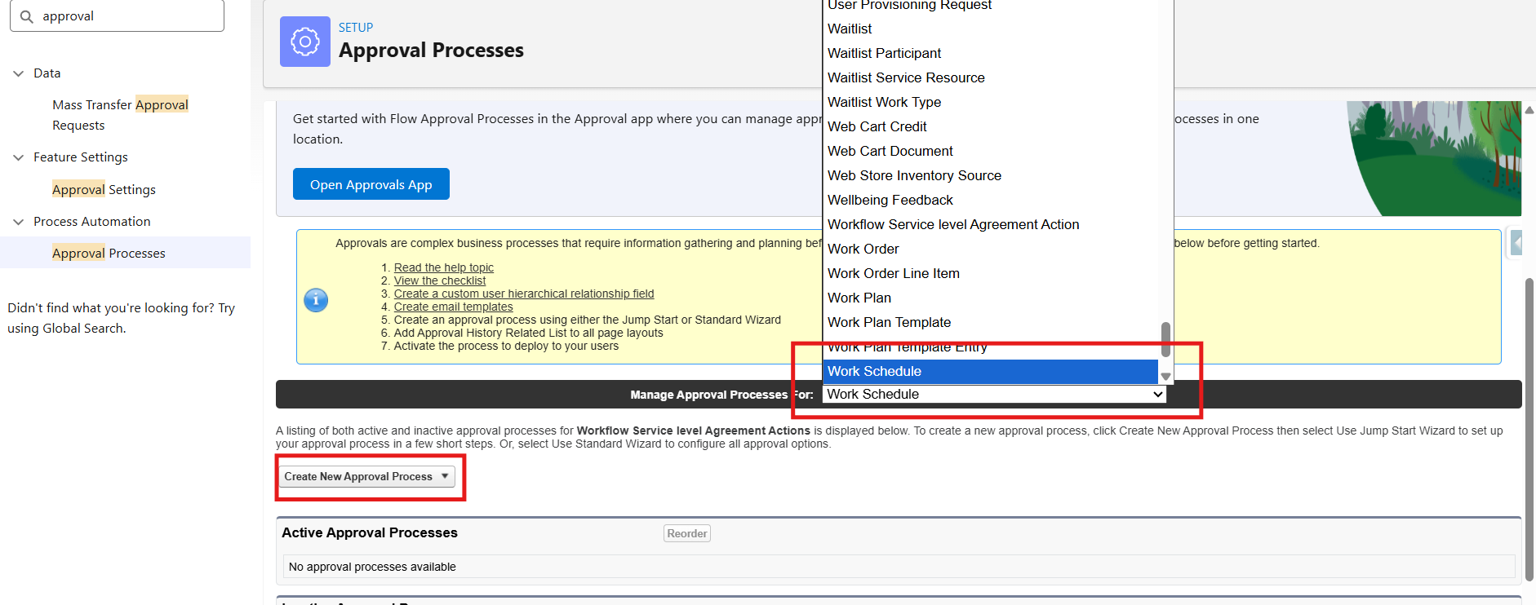

**Step 1: Basic Settings**

* Name: Approval Process for Work Schedule
* Unique Name: Auto-fills (you can keep it as is)
* Click Next

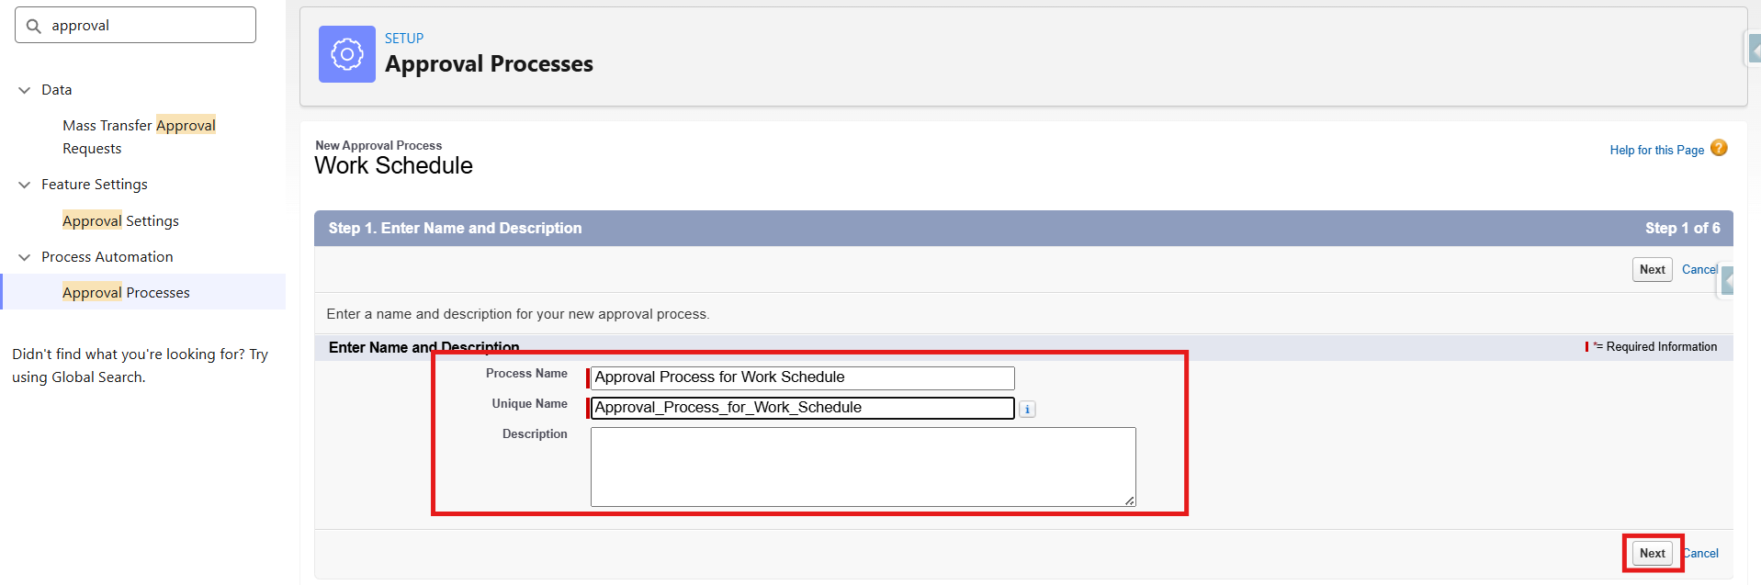

Specify Entry Criteria:

1.This defines when the process will be triggered.

* Choose "Criteria are met"

Set:

* Field: Work Schedule→ Approval Status
* Operator: Equals
* Value: Pending

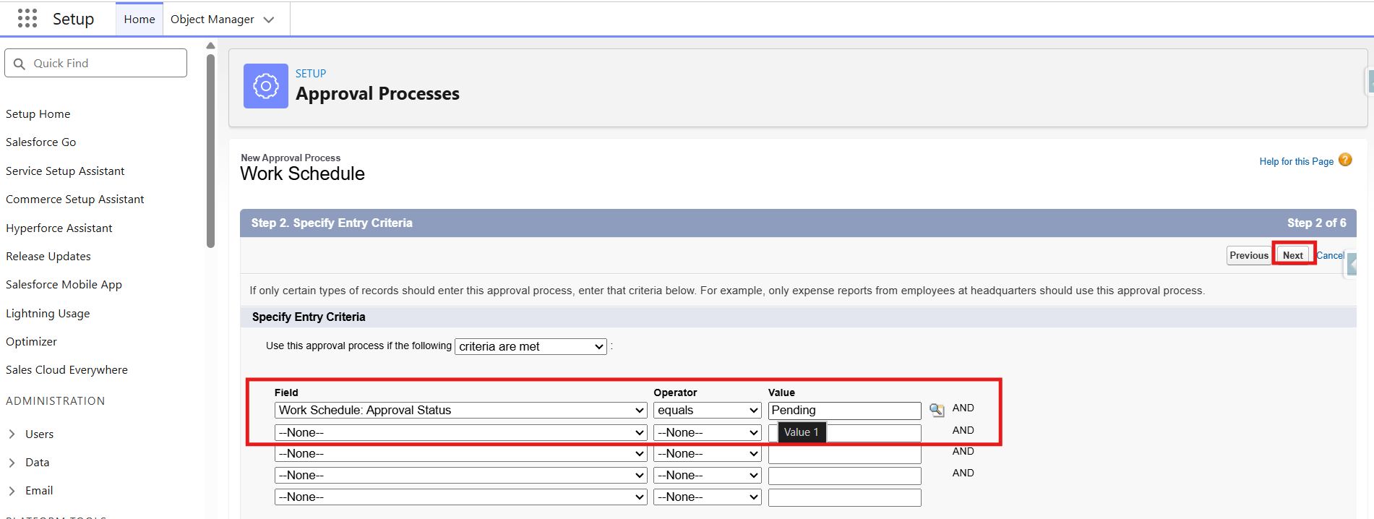

**Step 2: Select Approver**

* Select Administrators **ONLY** can edit records during the approval process

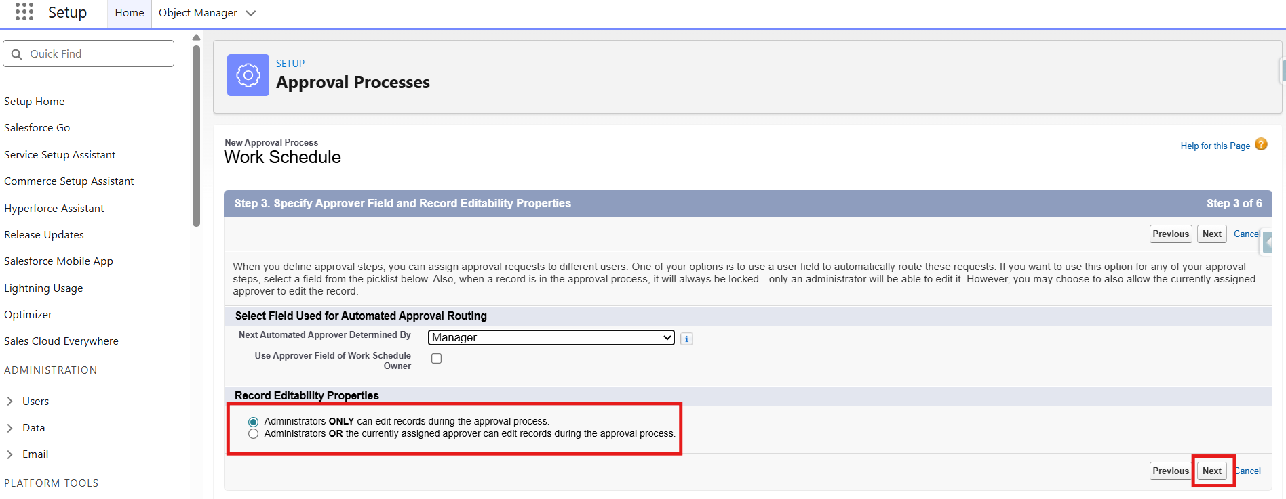

**Step 3: Email Template**

Approval Assignment Email Template:

* Select Email Template: Work Schedule Approval Notification to Approvers.

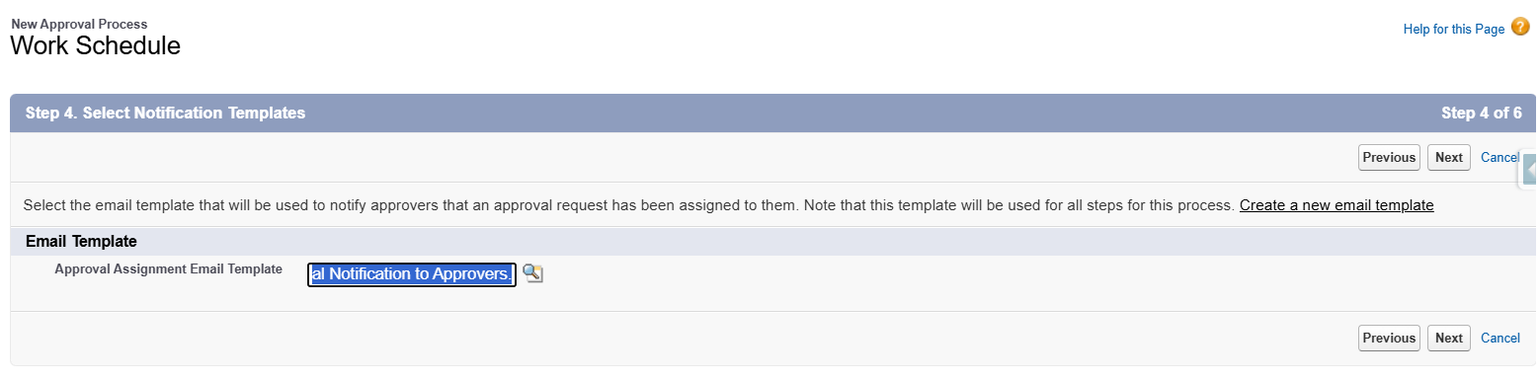

**Step 4: Select Fields to Display on Approval Page Layout**

You’ll see a dual list:

* Available Fields on the left
* Selected Fields on the right

Choose the fields you want approvers to see (typically key business info). Example for Leave Request:

Suggested Fields:

* Work Schedule Id
* Owner
* Employee
* Start Date
* End Date
* Manager
* Use the Add button to move fields from left to right.
* Use the Up/Down arrows to reorder how they appear.
* Click Next to proceed.

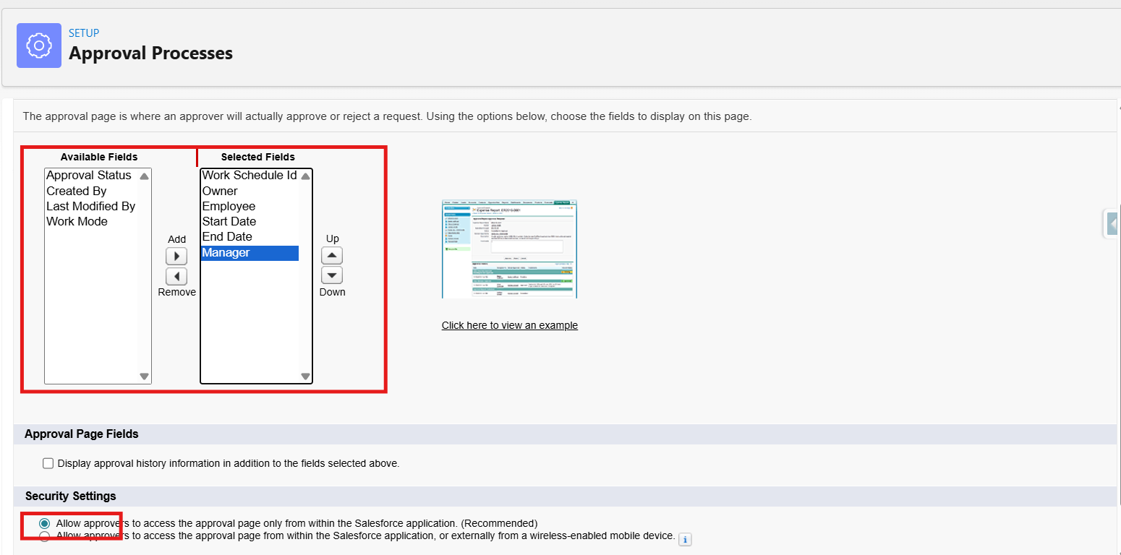

**Step 5: Specify Initial Submitters**

* search for owner and add Work Schedule owner to the selected submitters from available submitters.
* Click Save.

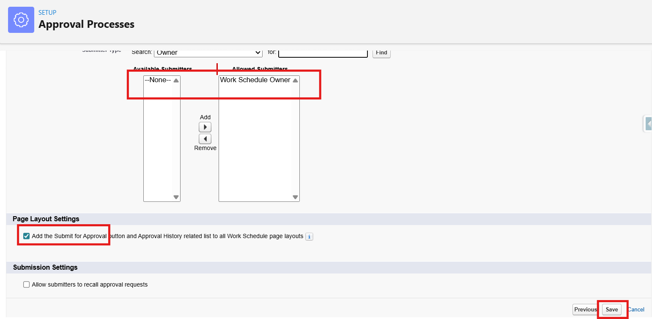

**Step 6: Final Approval Actions**

* Click Add New → Field Update



* Select Field to Update as Approval status.
* Name: Set Approval Status to Approved
* Field: Approval_Status__c
* New Value: Approved
* Save.

**Step 7: Final Rejection Actions**

* Click Add New → Field Update
* Name: Approval Status to Rejected
* Field: Approval_Status__c
* New Value: Rejected
* Save.

**Step 8: Activate the Approval Process**

* Click View Approval Process Detail Page
* Click the "Activate" button at the top

### **Activity 2: Create an Approval Process for Task Assignment**

### **Note:** Before Implementing Approval Process First Complete Profiles, Roles and Users Milestones.

**1.Create Classic Email Template**

* Go to Setup (gear icon on top-right)
* In the Quick Find box, type: Email Templates
* Click on Classic Email Templates
* Click "New Template"A screenshot of a computer

  AI-generated content may be incorrect.
  + You’ll now choose the type of email template you want to create.

Choose the type:

* Text – Plain text (no formatting)
* Click Next

Email Template Information:

|  |  |
| --- | --- |
| Folder | Public or private folder (use "Unfiled Public Email Templates" for now) |
| Email Template Name | Task Assignment Approval Notification for Approvers. |
| Template Unique Name | Auto-filled, or change it (no spaces) |
| Encoding | Leave default (UTF-8) |
| Subject | New Task Assignment Request Raised!! |
| Email Body | Dear {!Task_Assignment__c.Approver__c},  A new task assignment has been submitted and is awaiting your approval. Please review the details below:  **Task Details:**  - Assigned To: {!Task_Assignment__c.Employee__c}  - Task Title: {!Task_Assignment__c.Task_Title__c}  - Start Date: {!Task_Assignment__c.Start_Date__c}  - End Date: {!Task_Assignment__c.End_Date__c}  - Priority: {!Task_Assignment__c.Priority__c}  - Description: {!Task_Assignment__c.Description__c}  If you have any questions or need additional information, please contact the assigner directly.  Thank you for your prompt attention.  Best regards,  The Hybrid Workforce Team |

**2. Create the Approval Process**

* In the Quick Find box, type: Approval Processes
* Click on "Approval Processes" under Process Automation
* Click on the object name: Task Assignment
* Click Create New Approval Process → Use Standard Setup Wizard

**Step 1: Basic Settings**

* Name: Approval Process for Task Assignment
* Unique Name: Auto-fills (you can keep it as is)
* Click Next

Specify Entry Criteria:

1.This defines when the process will be triggered.

* Choose "Criteria are met"

Set:

* Field: Task Assignment→ Approval Status
* Operator: equal
* Value: Pending

**Step 2: Select Approver**

1. Select Administrators **OR** the currently assigned approver can edit records during the approval process.

**Step 3: Email Template**

Approval Assignment Email Template:

* Select Email Template: Task Assignment Approval Notification to Approvers email template

**Step 4: Select Fields to Display on Approval Page Layout**

You’ll see a dual list:

* Available Fields on the left
* Selected Fields on the right

Choose the fields you want approvers to see (typically key business info). Example for Campaign:

Suggested Fields:

* Task Assignment Id
* Owner
* Employee
* Task Title
* Use the Add button to move fields from left to right.
* Use the Up/Down arrows to reorder how they appear.
* Check Display approval history information in addition to the fields selected above checkbox
* Select Allow approvers to access the approval page only from within the Salesforce application. (Recommended)
* Click Next to proceed.

**Step 5: Specify Initial Submitters**

* search for owner and add Task Assignment owner to the selected submitters from available submitters.
* Click Save.

**Step 6: Final Approval Actions**

* Click Add New → Field Update



* Select Field to Update as Approval status.
* Name: Set Approval Status to Approved
* Field: Approval_Status__c
* New Value: Approved
* Save.

**Step 7: Final Rejection Actions**

* Click Add New → Field Update
* Name: Approval Status to Rejected
* Field: Approval_Status__c
* New Value: Rejected
* Save.

**Step 8: Activate the Approval Process**

* Click View Approval Process Detail Page

Click the "Activate" button at the top

## **Milestone 7 – Apex Classes**

**Activity1: Create an apex class WorkScheduleController**

Create Apex Class

Retrieves work schedules and creates new entries.

1. Click Gear Icon and Select Developer Console

Click on File and Click New and Click on Apex class

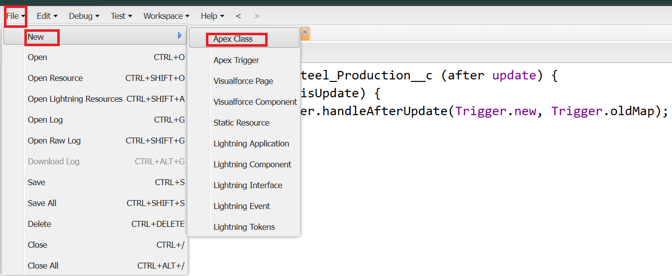

Give name as WorkScheduleController and Click Ok

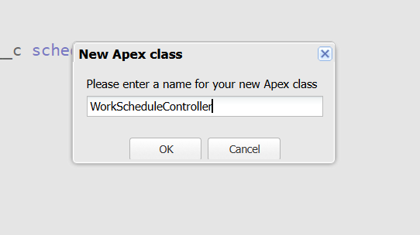

Write Whole code in the class

Source Code:

public class WorkScheduleController {

@AuraEnabled(cacheable=true)

public static List<Work_Schedule__c> getSchedulesForUser() {

Id contactId = [SELECT Id FROM Contact WHERE Email = :UserInfo.getUserEmail() LIMIT 1].Id;

return [SELECT Id, Work_Mode__c, Start_Date__c, End_Date__c, Manager__r.Name

FROM Work_Schedule__c WHERE Employee__c = :contactId];

}

@AuraEnabled

public static Id createSchedule(Work_Schedule__c schedule) {

insert schedule;

return schedule.Id;

}

}

Save the class using CTRL+S

**Activity2: Create an apex class which Handles attendance data for daily logs.**

Create Apex Class

1. Click Gear Icon and Select Developer Console
2. Click on File and Click New and Click on Apex class
3. Give name as AttendanceController and Click Ok

Write whole code in the class

Source Code:

public class AttendanceController {

@AuraEnabled

public static Id logAttendance(Attendance_Log__c attendance) {

insert attendance;

return attendance.Id;

}

@AuraEnabled(cacheable=true)

public static List<Attendance_Log__c> getUserAttendance() {

Id contactId = [SELECT Id FROM Contact WHERE Email = :UserInfo.getUserEmail() LIMIT 1].Id;

return [SELECT Id, Check_In_Time__c, Check_Out_Time__c, Work_Mode__c

FROM Attendance_Log__c WHERE Employee__c = :contactId ORDER BY Check_In_Time__c DESC];

}

}

Save the class using CTRL+S

**Activity3: Create an apex class which is Used for capturing and viewing feedback trends.**

Create Apex Class

1. Click Gear Icon and Select Developer Console
2. Click on File and Click New and Click on Apex class
3. Give name as WellbeingFeedbackController and Click Ok

Write whole code in the class

Source Code:

public class WellbeingFeedbackController {

@AuraEnabled(cacheable=true)

public static List<Wellbeing_Feedback__c> getFeedbackHistory() {

Id contactId = [SELECT Id FROM Contact WHERE Email = :UserInfo.getUserEmail() LIMIT 1].Id;

return [SELECT Id, Feedback_Date__c, Rating__c, Comments__c

FROM Wellbeing_Feedback__c WHERE Employee__c = :contactId ORDER BY Feedback_Date__c DESC];

}

}

Save the class using CTRL+S.

**Milestone8: Asynchronous Apex**

**Activity1: Create an async apex class which automatically sends policy update notifications asynchronously to users.**

Create an apex class:

public class SendPolicyUpdates implements Queueable {

public void execute(QueueableContext context) {

List<User> users = [SELECT Id, Email FROM User WHERE IsActive = TRUE];

Messaging.SingleEmailMessage[] emails = new List<Messaging.SingleEmailMessage>();

for (User u : users) {

Messaging.SingleEmailMessage mail = new Messaging.SingleEmailMessage();

mail.setToAddresses(new String[]{u.Email});

mail.setSubject('New Hybrid Policy Update');

mail.setPlainTextBody('A new hybrid policy has been added or updated. Please review in the portal.');

emails.add(mail);

}

Messaging.sendEmail(emails);

}

}

**Milestone9: Email Templates**

**Activity1: Create a Hybrid Work Schedule Approval Email Template**

1. Go to **Setup** (gear icon on top-right).
2. In the Quick Find box, type **Email Templates**.
3. Click on **Classic Email Templates**.
4. Click **New Template**.

**Choose the type:**

* Text – Plain text (no formatting)
* Click **Next**

Template Name: Hybrid Work Schedule Approval

Subject: Work Schedule Request Pending Your Approval

Body:

Dear {!Work_Schedule__c.Manager__c},

A new hybrid work schedule request has been submitted and is awaiting your approval. Please review the details below:

**Request Details:**

- Employee Name: {!Work_Schedule__c.Employee__c}

- Schedule Duration: {!Work_Schedule__c.Start_Date__c} to {!Work_Schedule__c.End_Date__c}

- Work Mode: {!Work_Schedule__c.Work_Mode__c} (Office / Remote / Flexible)

- Reason for Schedule: {!Work_Schedule__c.Reason__c}

To approve or reject this schedule, please click the link below to access the Work Schedule record in Salesforce:

{!Work_Schedule__c.Link}

If you have any questions or need additional clarification, please reach out directly to the employee.

Thank you for your prompt attention.

Best regards,

HR & Administration Team

**Activity2: Create a Policy Update Notification Email Template**

1. Go to **Setup** (gear icon on top-right).
2. In the Quick Find box, type **Email Templates**.
3. Click on **Classic Email Templates**.
4. Click **New Template**.

**Choose the type:**

* Text – Plain text (no formatting)
* Click **Next**

Template Name: Policy Update Notification

Subject: New Hybrid Work Policy Added

Body:

Dear {!User.Name},

A new hybrid work policy has been published in the Employee Portal. Please review the latest policy at your earliest convenience to ensure compliance.

**Policy Details:**

- Policy Title: {!Policy__c.Name}

- Category: {!Policy__c.Category__c} (HR / Compliance / IT / General)

- Effective Date: {!Policy__c.Effective_Date__c}

- Description: {!Policy__c.Description__c}

- Document Link: {!Policy__c.Document_Link__c}

You can access the full policy under the HR → Hybrid Policies section in your Employee Portal.

It is mandatory for all employees to review and adhere to the new policy guidelines. If you have any questions, please contact your HR representative.

Thank you,

HR Department

**Milestone 10: Declarative Automation (Flows)**

**Activity 1: Work Schedule Approval Flow**

**Objective:** Automatically send approval request to manager when a new work schedule is created.

**Steps:**

1. From Setup, in the Quick Find box, search for Flows.
2. Click New Flow.

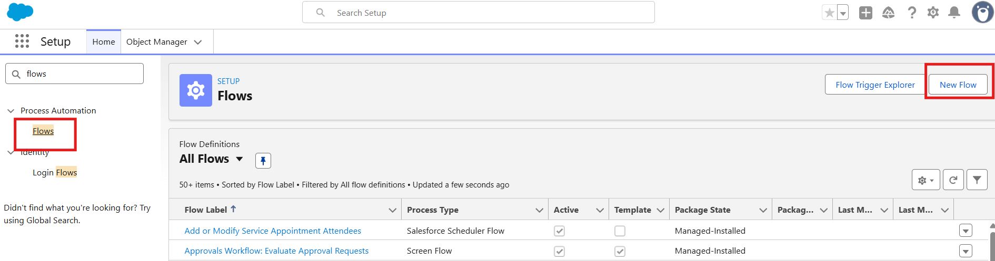

1. Select Category: Triggered.
2. Select Type: Record-Triggered Flow.
3. Select Object: Work_Schedule__c.

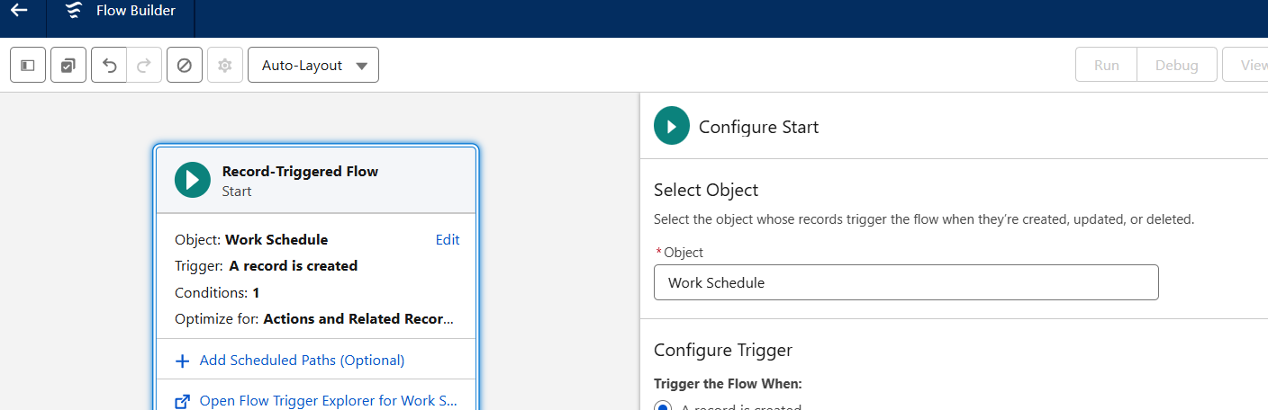

1. Configure Trigger: When a record is created.
2. Set Entry Conditions: Approval_Status__c = Pending.
3. Run Every time a record is created and meets the condition requirements.
4. Optimize flow for Actions and Related Records.

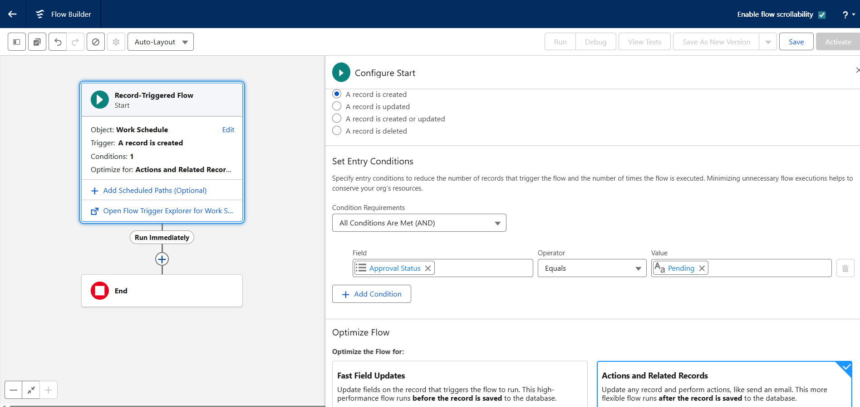

1. Click on + Icon and add an Action Element.
2. For Label, enter: Send Approval Request.
3. Select Email Template: Hybrid Work Schedule Approval.
4. Map Manager Id to the Approver field.
5. Save the Flow and Activate.

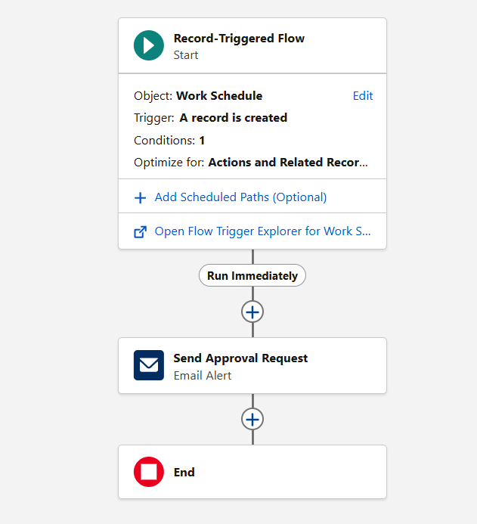

**Activity 2: Attendance Log Calculation Flow**

**Objective:** Automatically calculate total working hours when employee enters Check-out time.

**Steps:**

1. From Setup, in the Quick Find box, search for Flows.
2. Click New Flow.
3. Select Category: Triggered.
4. Select Type: Record-Triggered Flow.
5. Select Object: Attendance_Log__c.
6. Configure Trigger: When a record is updated.
7. Set Entry Conditions: Check_Out_Time__c Is Changed = True.
8. Run Every time a record is updated and meets the condition requirements.
9. Optimize flow for Actions and Related Records.
10. Click on + Icon and add an Assignment Element.
11. Assign Total_Work_Hours__c = Check_Out_Time__c - Check_In_Time__c.
12. Save the Flow and Activate.

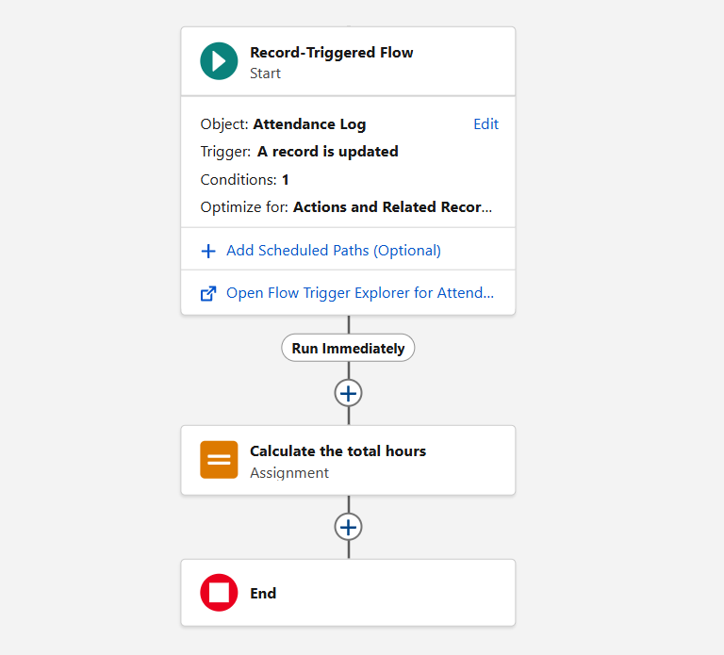

**Summary:**

This phase successfully established the backend for managing hybrid workforce operations.  
With well-defined data models, Apex logic, declarative automation, and security controls, the system now supports real-time hybrid scheduling, attendance tracking, and engagement analytics.

This foundation ensures that future phases (UI development with LWC and Experience Site deployment) will integrate seamlessly with existing logic and data structures.

# **Phase 3: UI/UX Development & Customization**

## The UI/UX Development & Customization phase focused on building an intuitive and responsive interface for the Hybrid Workforce Project. The goal was to deliver a seamless user experience for employees and managers to access and manage hybrid schedules, attendance logs, wellbeing feedback, policies, announcements, and task assignments.

## During this phase, Lightning Application and Page Layouts were created and customized to ensure smooth navigation and a connected design aligned with organizational branding.

## **Milestone 11: The Lightning App**

## 

### **Activity 1: Create a Lightning App for “Hybrid Workforce Portal”**

**“**From Setup, enter App Manager in the Quick Find and select App Manager.

1. Click New Lightning App.

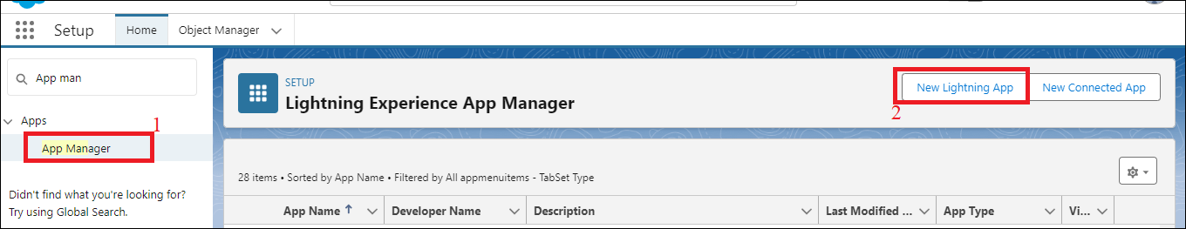

1. Enter **Hybrid Workforce Portal** as the App Name >> Click on upload image and add an image related to Hybrid workforce then click next

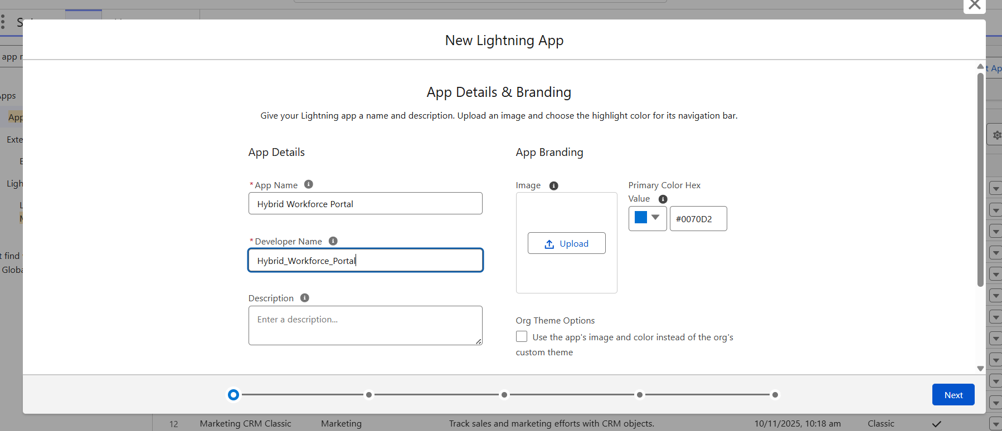

1. Under App Options, leave the default selections and click next.

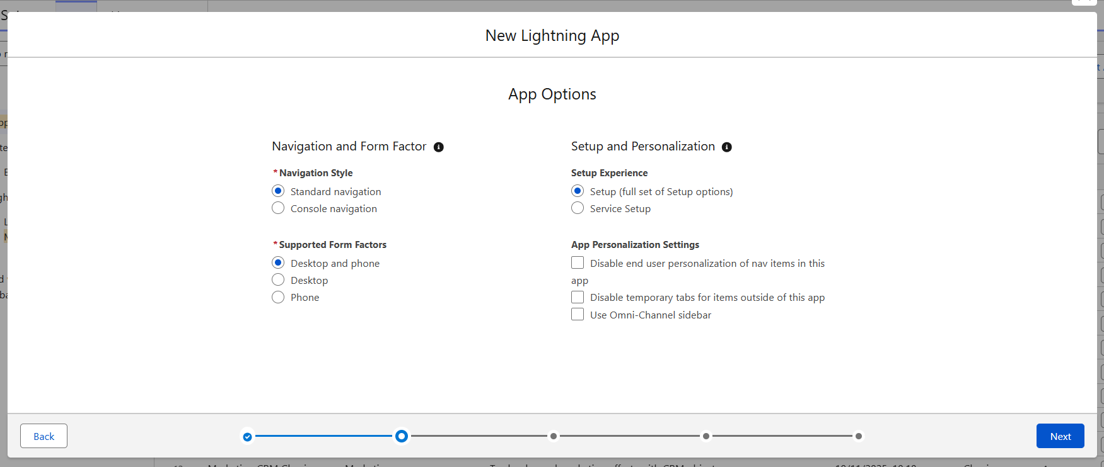

1. Under Utility Items, leave as is and click Next.

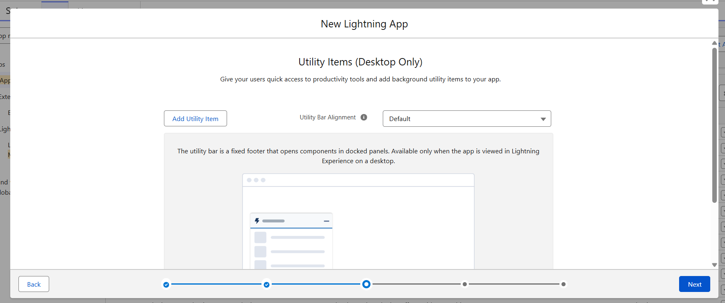

1. From Available Items, select

**Work_Schedule__c, Attendance_Log__c, Wellbeing_Feedback__c, Hybrid_Policy__c, Announcements__c, Task_Assignment__c**

and move them to Selected Item and Click Next.

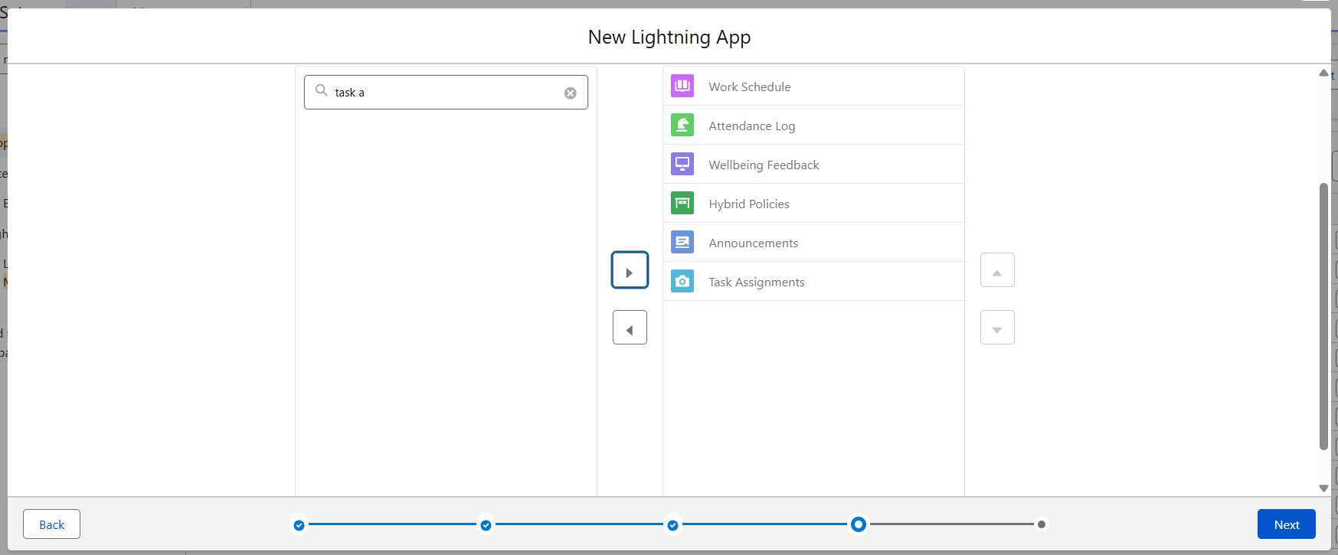

1. From Available Profiles, select System Administrator and move it to Selected Profiles.

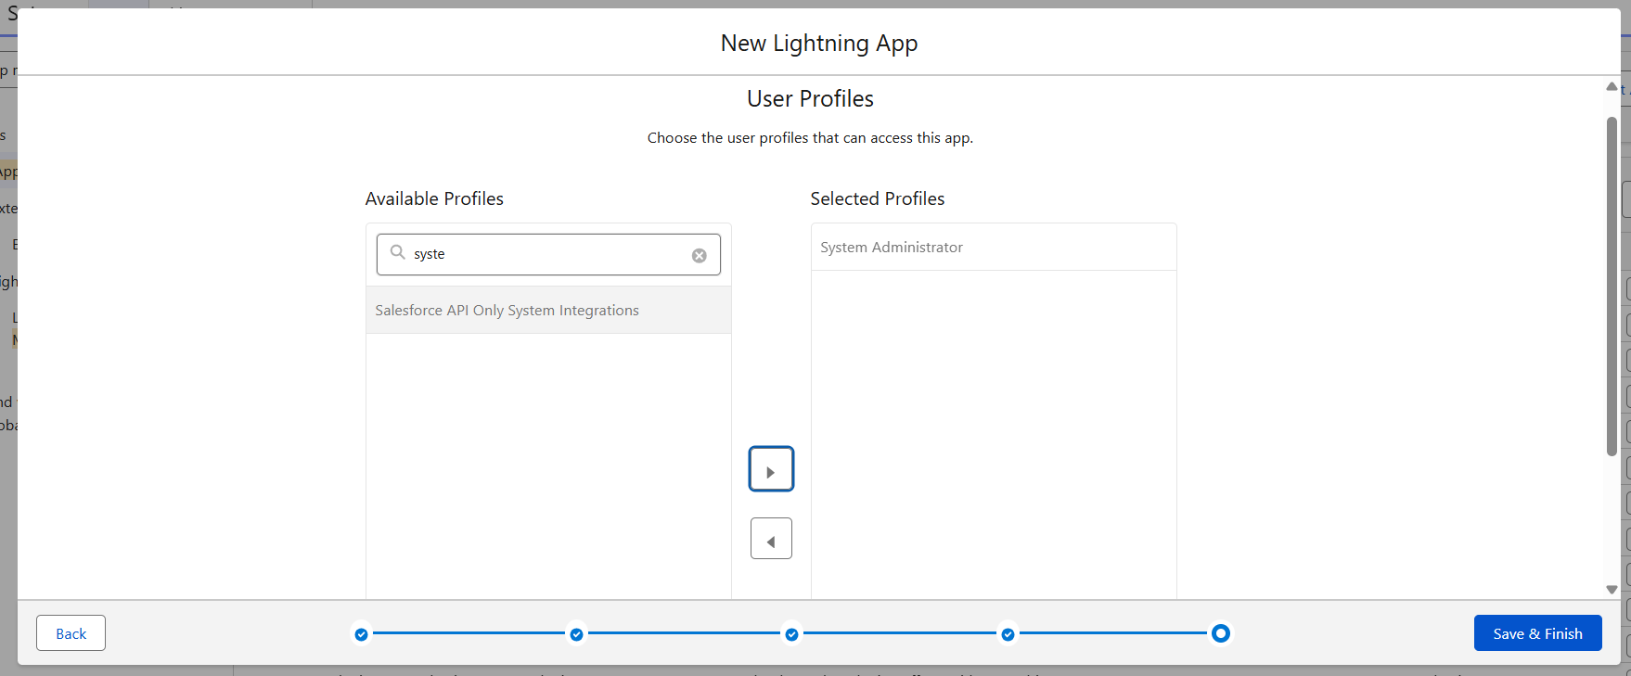

1. Click Save & Finish.

## **Milestone 12 -Editing of Page Layouts**

### **Activity 1: To edit a Page Layout in Work_Schedule__c Object**

1. Go to setup >> click on Object Manager >> type object name (Work Schedule) in quick find box >> click on the Work Schedule object >> Page Layouts.
2. Click on the Work Schedule Layout.
3. Drag and arrange the field as shown below.

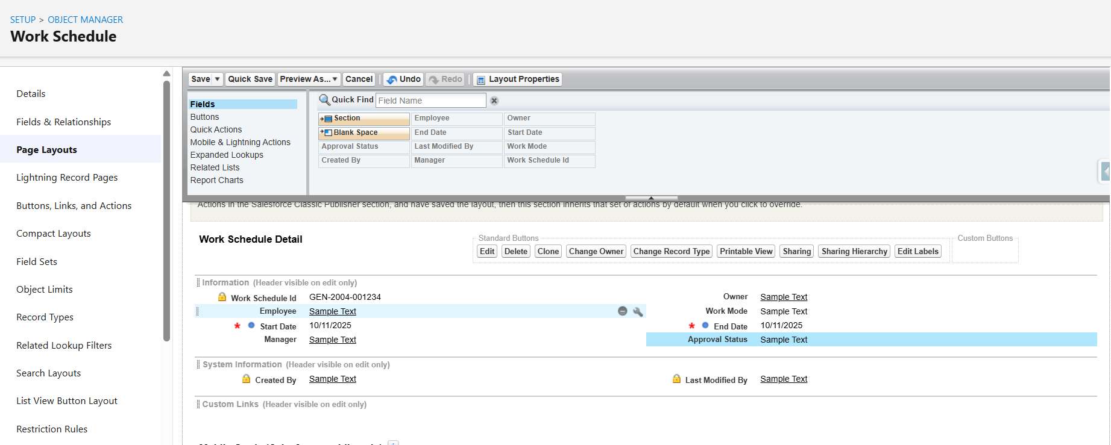

4. Click on Save.

### **Activity 2: To edit a Page Layout in Attendance_Log__c Object**

1. Go to setup >> click on Object Manager >> type object name (Attendance Log) in quick find box >> click on the Attendance Log object >> Page Layouts.
2. Click on the Attendance Log Layout
3. Drag and arrange the field as shown below

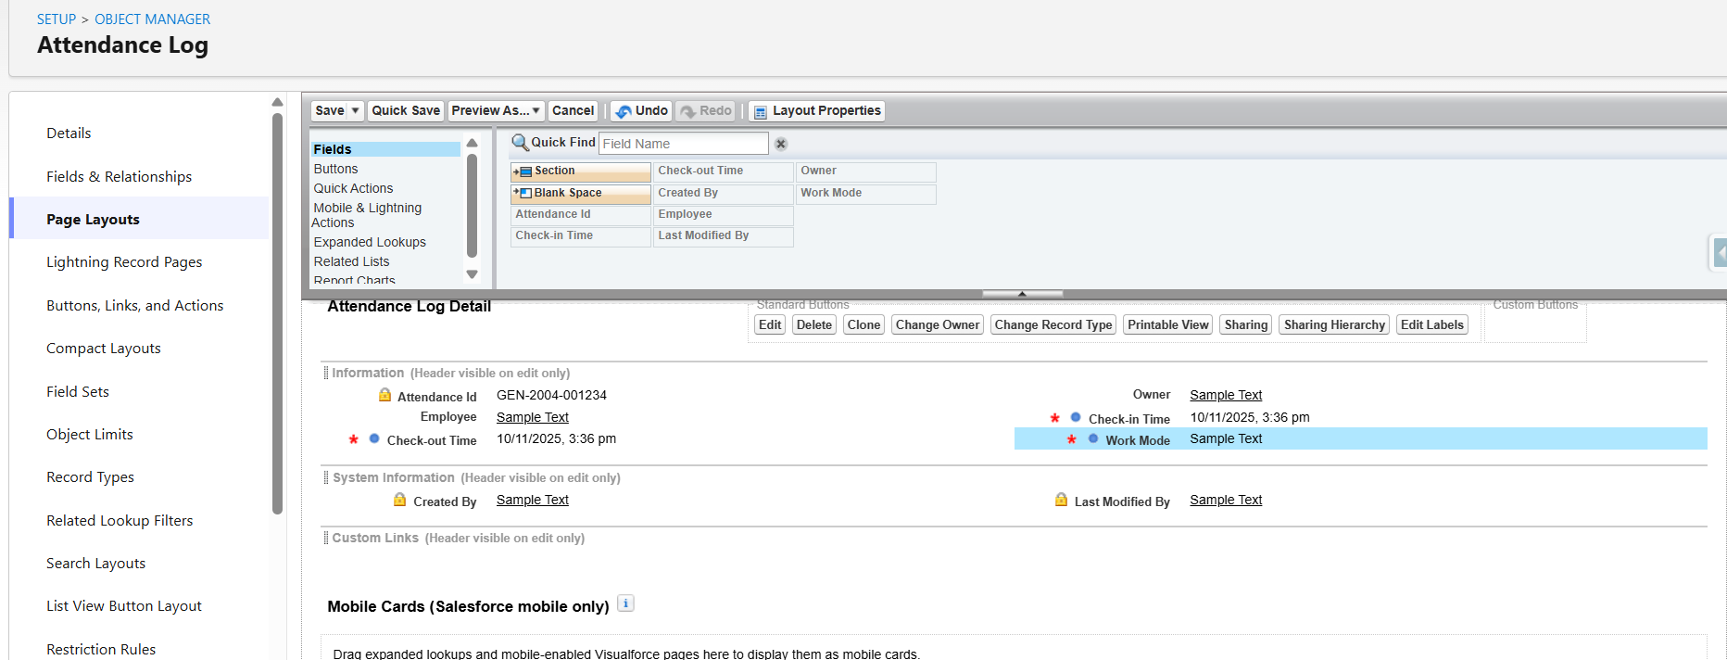

1. Click Save.

### **Activity 3: To edit a Page Layout in Wellbeing_Feedback__c Object**

1. Go to setup >> click on Object Manager >> type object name (Wellbeing Feedback) in quick find box >> click on the Wellbeing Feedback object >> Page Layouts.
2. Click on the Wellbeing Feedback Layout
3. Drag and arrange the field as shown below

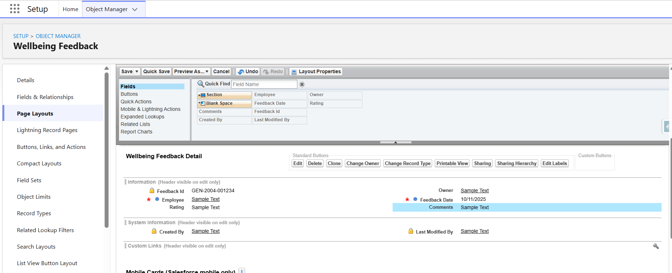

1. Click Save.

### **Activity 4: To edit a Page Layout in Hybrid_Policy__c Object**

1. Go to setup >> click on Object Manager >> type object name (Hybrid Policy) in quick find box >> click on the Hybrid Policy object >> Page Layouts.
2. Click on the Hybrid Policy Layout
3. Drag and arrange the field as shown below

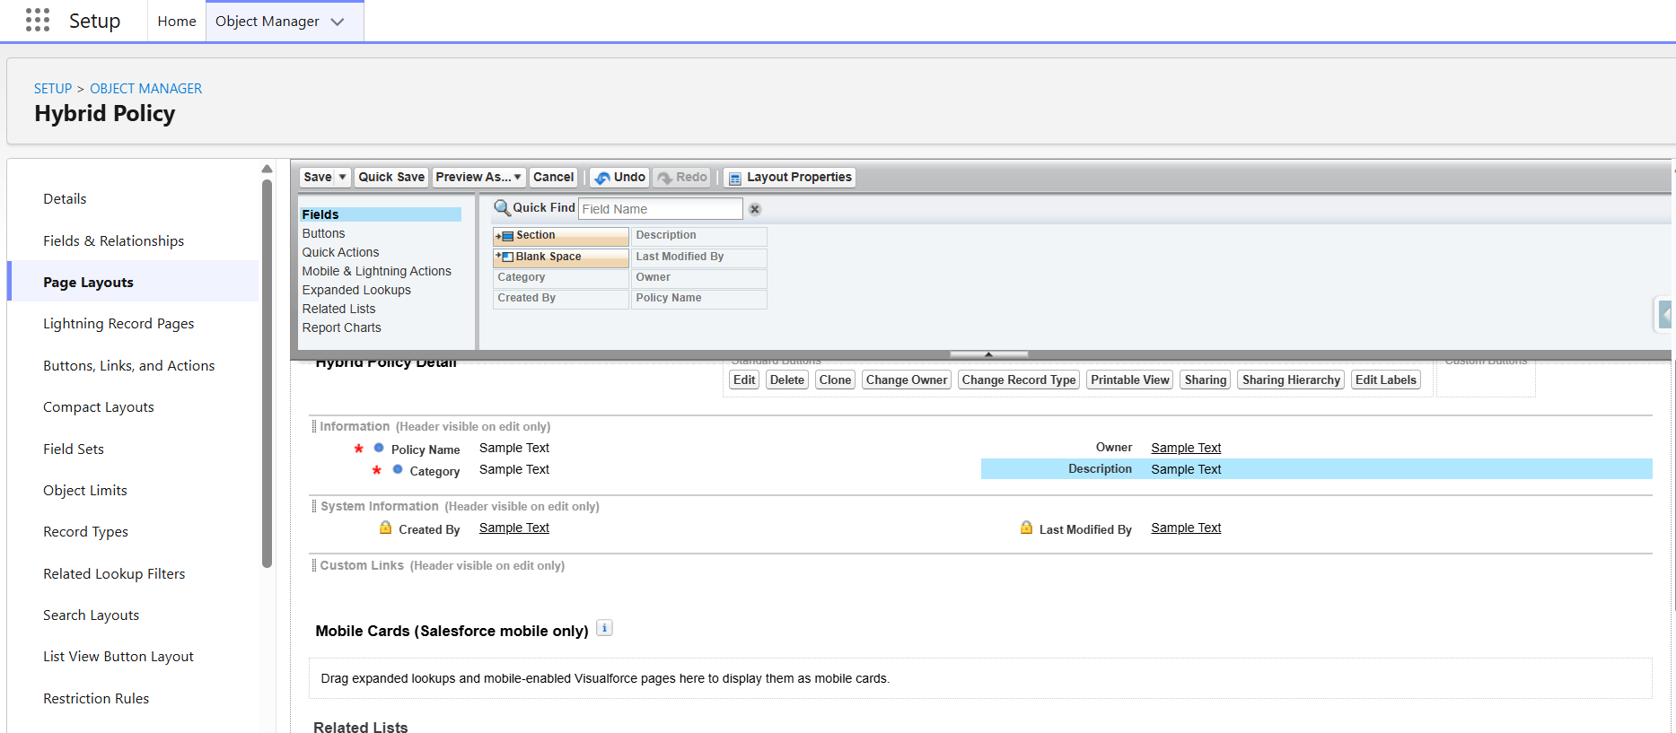

1. Click Save

### **Activity 5: To edit a Page Layout in Announcement__c Object**

1. Go to setup >> click on Object Manager >> type object name (Announcement) in quick find box >> click on the Announcement object >> Page Layouts.
2. Click on the Announcement Layout
3. Drag and arrange the buttons as shown below

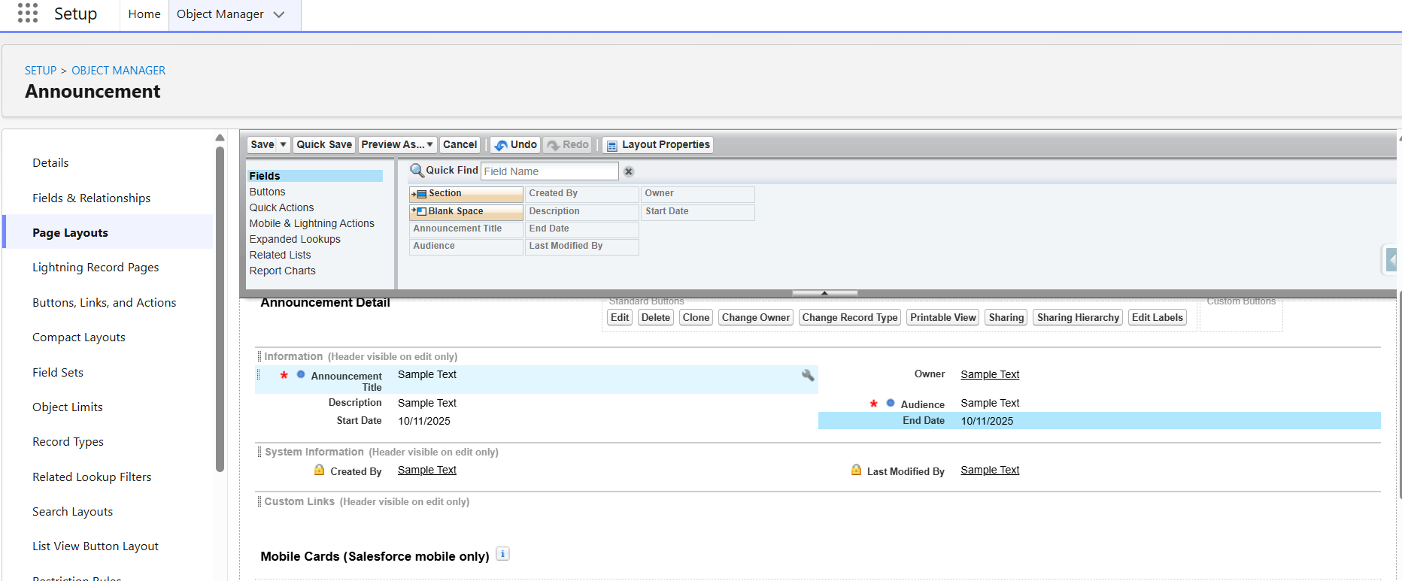

Click Save.

### **Activity 6: To edit a Page Layout in Task_Assignment__c Object**

1. Go to setup >> click on Object Manager >> type object name (Task Assignment) in quick find box >> click on the Task Assignment object >> Page Layouts.
2. Click on the Task Assignment Layout
3. Drag and arrange the field as shown below

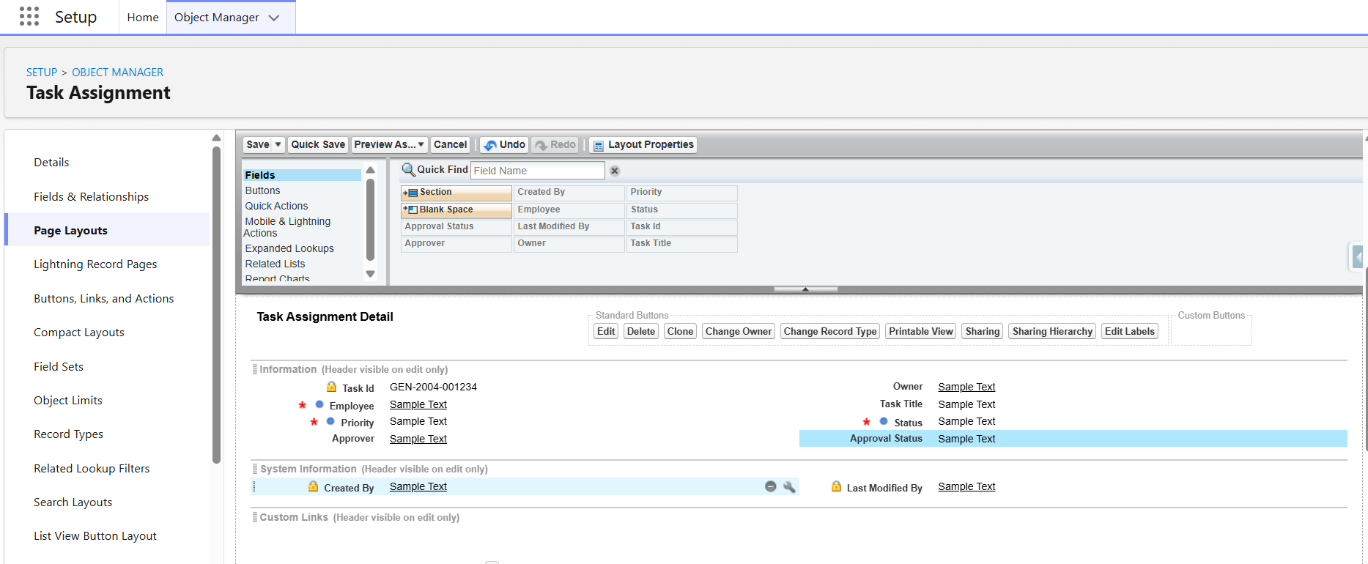

1. Click Save.

## **Milestone 13 - Dynamic Forms**

### **Activity 1: To create a Dynamic Form in Work Schedule Object**

1. Go to setup >> click on App Launcher >> Open “Hybrid Workforce Portal”App >> click on the **Work Schedule** object tab>> Click on New and create a new record and save it .
2. Click on the record created and click on the Gear icon on the top right corner and Select **Edit Page**.
3. Click on the Details section and on the right pane click on **Upgrade Now** to enable Dynamic Forms for the object.
4. Select Work Schedule PageLayout and Click on Finish.
5. Click on Save and Click on Activate.
6. Click on Org as Default, select Desktop and Phone, click Next and Click Save.

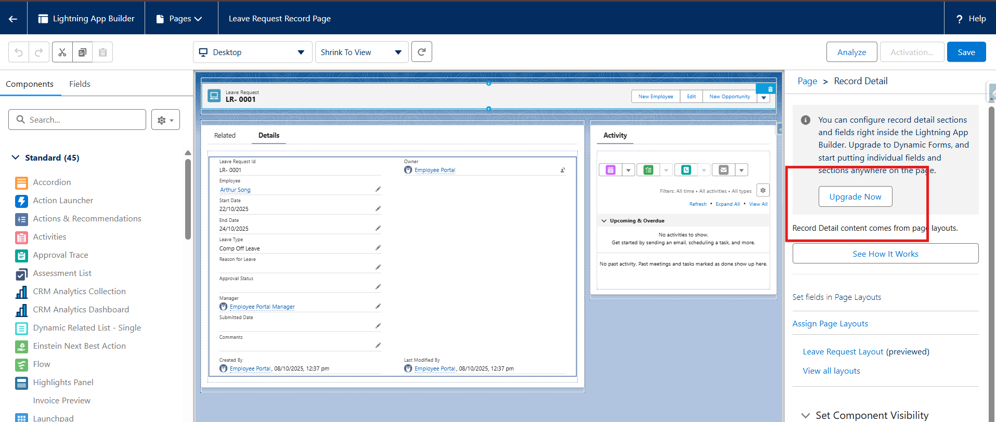

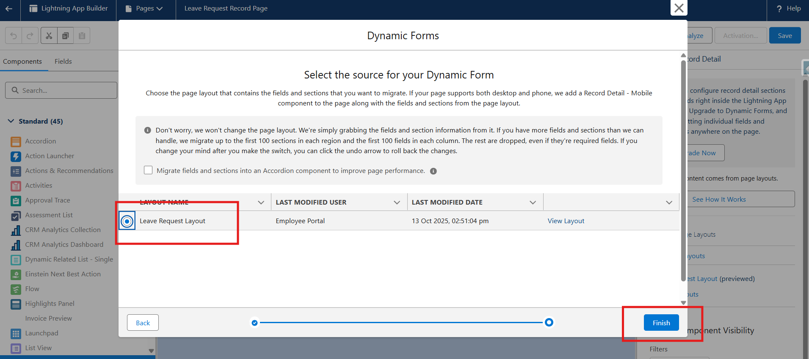

1. Do the same for remaining objects as well.

## **Milestone14:Users** A user is anyone who logs in to Salesforce. Users are employees at your company, such as sales reps, managers, and IT specialists, who need access to the company's records. Every user in Salesforce has a user account. The user account identifies the user, and the user account settings determine what features and records the user can access.

### **Activity 1: Create User**

**Note:** Before Implementing Users first complete Profiles and Roles Milestones.

1. Go to setup >> type users in quick find box >> select users >> click new user.
2. Fill in the fields
3. First Name : Hybrid Workforce
4. Last Name : Manager
5. Alias : Give an Alias Name
6. Email id : Give your Personal Email id
7. Username : Username should be in this form: text@text.text and it must be Unique.
8. Nick Name : Give a Nickname
9. Role : Hybrid Workforce Manager
10. User license : Salesforce
11. Profiles : Manager Profile
12. Save.

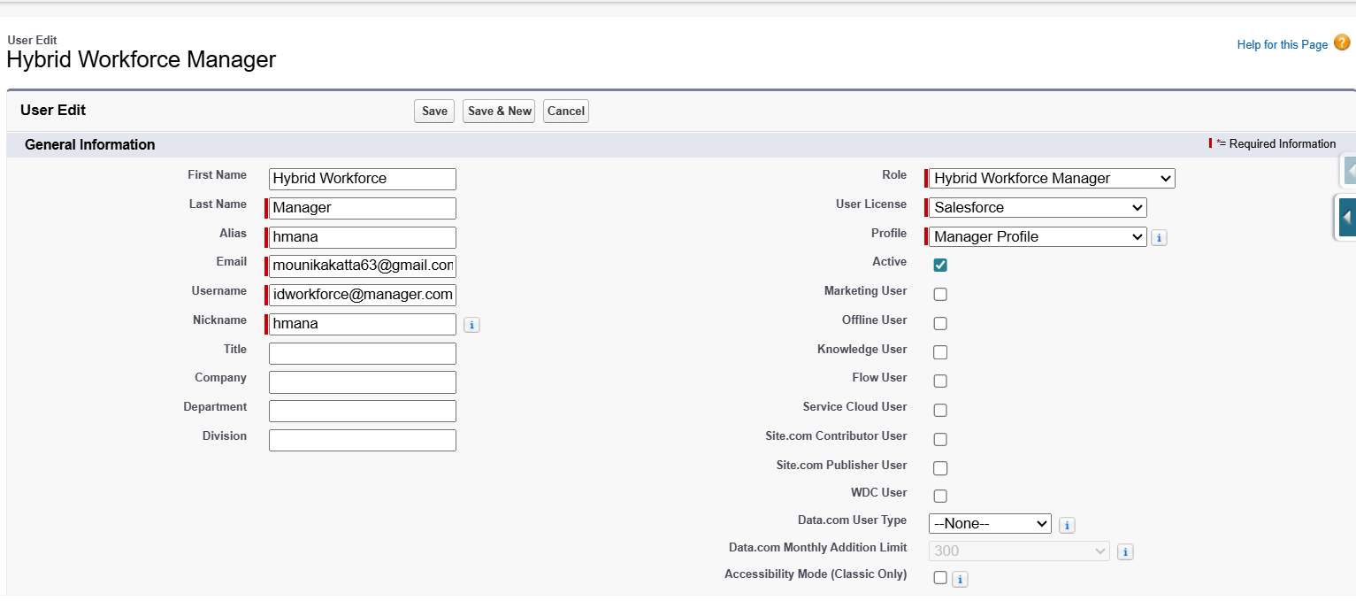

### **Activity 2: creating other users**

1. Repeat the steps and create other users using
   1. Role : Hybrid Workforce Employee
   2. User license : Salesforce
   3. Profile : Employee Profile

# **Phase 4: Data Migration, Testing & Security**

Data Migration, Testing & Security focuses on migrating data from legacy systems or spreadsheets into Salesforce, ensuring data integrity, and configuring security measures for the Hybrid Workforce Portal. This phase also involves testing all functionalities, including schedules, attendance logs, wellbeing feedback, hybrid policies, announcements, and task assignments. Security settings such as role-based access, sharing rules, and field-level security are applied to protect sensitive information and ensure compliance.

**Performance Tuning & Optimization**This phase also focused on optimizing performance, ensuring smooth operation of the portal even with multiple concurrent users accessing schedules, attendance logs, feedback, tasks, and policies.

**1. Data Migration**

The Hybrid Workforce Portal requires migration of employee schedules, attendance, wellbeing feedback, tasks, policies, and announcements from legacy systems or spreadsheets into Salesforce.

**Steps Followed:**

* Imported employee records (Contact data) using **Data Import Wizard** and **Data Loader**.
* Imported related records: Work_Schedule__c, Attendance_Log__c, Wellbeing_Feedback__c, Hybrid_Policy__c, Announcements, and Task_Assignment__c.
* Ensured unique identifiers (Employee ID, Email) to prevent duplicates.
* Validated lookup relationships between employees, schedules, attendance logs, and tasks.
* Verified data integrity using reports and dashboards after migration.

**Data Validations:**

* Mandatory fields (Employee Name, Email, Schedule, Task Assignment) verified for completeness.
* Duplicate prevention using unique constraints on Employee Email and Employee ID.
* Validation Rules and Before Save Flows ensured accurate data entry for attendance, wellbeing, and task assignments.

**2. Testing**

Testing ensured all objects, Flows, and Apex logic performed correctly and integrated seamlessly.

**Testing Types Conducted:**

**Unit Testing**

* Verified Apex classes and Flows for Work Schedule creation, Attendance Logging, Wellbeing Feedback submission, Task Assignment tracking.
* Checked best practices and governor limits compliance.
* Ensured test classes achieved 100% coverage for triggers and Apex handlers.

**Integration Testing**

* Verified relationships between User records and related Work_Schedule__c, Attendance_Log__c, Wellbeing_Feedback__c, Task_Assignment__c.
* Tested interaction between Flows, page layouts, and backend Apex logic.

**User Acceptance Testing (UAT)**

* Conducted with sample employee and manager users to simulate real-life scenarios:
* Submitting attendance logs and wellbeing feedback
* Viewing schedules and announcements
* Accessing hybrid policies
* Completing assigned tasks

Collected feedback and optimized page layouts, validation messages, and navigation for better usability.

**Outcome:**All test cycles confirmed functional reliability, data accuracy, and smooth user interaction across desktop and mobile devices.

**3. Security Implementation**

Security ensured only authorized employees and managers could access appropriate records.

**Role Hierarchy**

* **Admin** – Full access to all records and configuration.
* **Manager** – Access to schedules, attendance, tasks, and feedback for employees under their supervision.
* **Employee** – Access limited to their own schedules, attendance, wellbeing feedback, and tasks.

**Profiles & Permission Sets**

* Profiles for Admin, Manager, Employee.
* Permission sets for additional access to hybrid policies, announcements, and task assignments.

**Field-Level Security**

* Sensitive fields (e.g., Employee Contact Info, HR Notes) hidden for employees but visible to Managers and Admins.

**Record-Level Security**

• OWD = Private for Work_Schedule__c, Attendance_Log__c, Wellbeing_Feedback__c, Task_Assignment__c.

• Sharing Rules: Managers get read/write access to manage employee data.

**Outcome of Phase 4**

* Data security, access control, and compliance verified before deployment.

**Performance Tuning & Optimization**

Performance Tuning & Optimization focused on enhancing the overall speed and efficiency of the Hybrid Workforce Portal, ensuring smooth performance even with multiple users accessing forms, and dashboards simultaneously.

**1. Optimizing SOQL Queries**

In Apex handlers and backend logic:

* Retrieved only required fields.
* Used selective filters based on logged-in employee.
* Applied LIMIT and WHERE clauses for efficiency.

**2. Reducing Loops and DML Operations**

* Avoided SOQL/DML inside loops.
* Batched updates in Apex and Flows.

**3. Page Layout Optimization**

* Modular page layouts for Work Schedule, Attendance Log, Wellbeing Feedback, Task Assignment, Hybrid Policies, and Announcements.
* Minimized unnecessary queries by using formula fields and roll-up summary fields where applicable.

**4. Security & Caching Enhancements**

* FLS checks in Apex.
* Platform Cache for frequently accessed policy and announcement data.

## **Milestone 15 - Duplicate and Matching rules**

### **Activity 1: Create a Custom Matching Rule:**

1. Go to Setup
2. In Quick Find, search for Matching Rules
3. Click New Rule

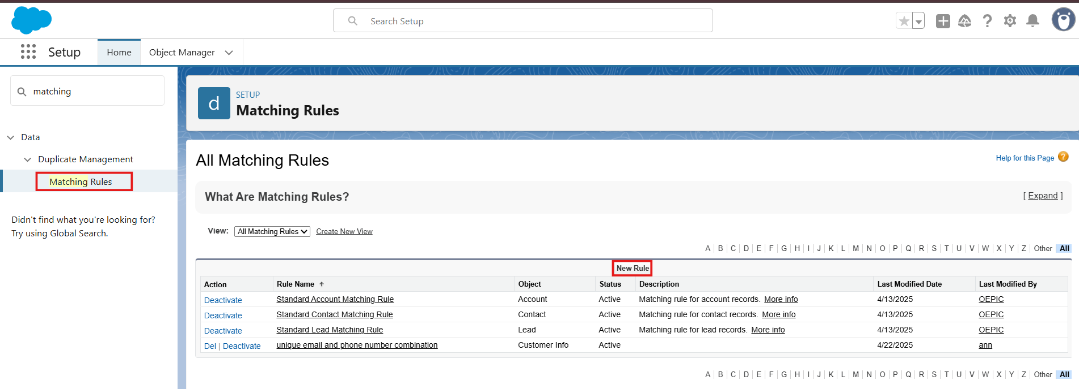

1. Select Object: Contact and Click Next
2. Enter Rule Name: Unique Email and Phone Number Combination
3. In Matching Criteria: Select Field as Email and Phone.
4. In Matching Method: Select Exact
5. Check The Match Blank Fields
6. Click Next
7. Click Save & Activate.

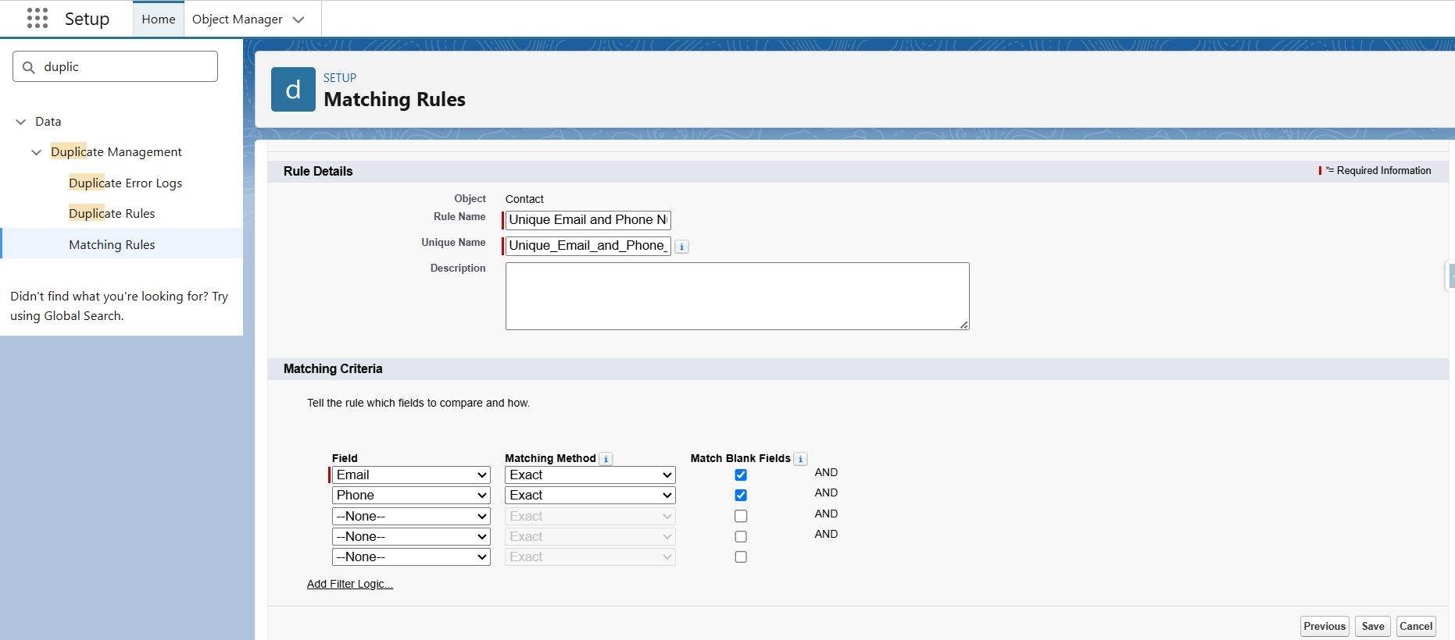

### **Activity 2: Create a Duplicate Rule**

1. Go to Setup
2. Search for Duplicate Rule
3. Click New Rule

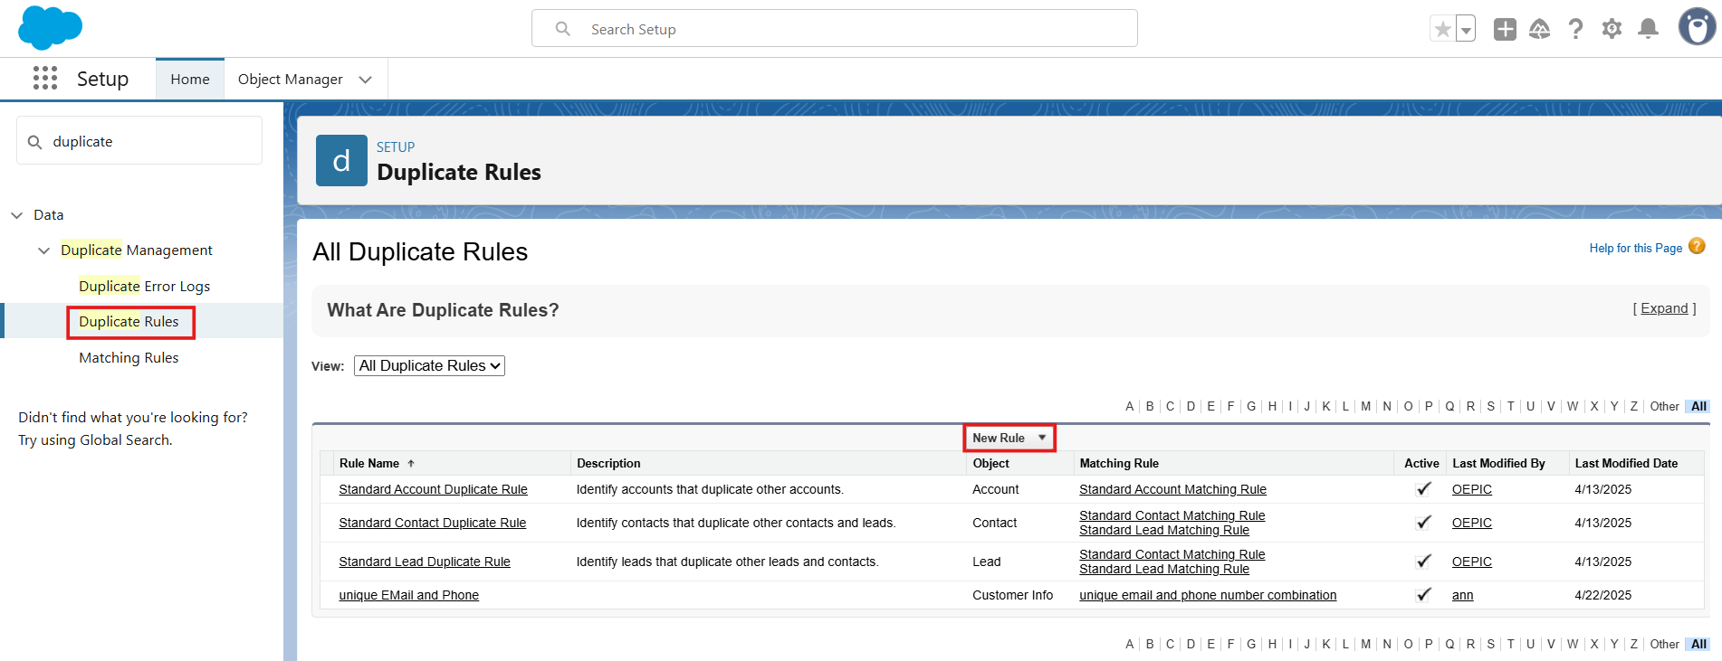

1. Select Object: Same as before (Contact)
2. Enter Rule Name: unique Email and Phone
3. Set Action on Create and Action on Edit: Allow and Report
4. In Alert Text: Email and Phone must be Unique
5. In the Matching Rules section:
6. Click Add Rule
7. Select your previously created Matching Rule (Unique Email and Phone Number Combination)
8. Click Save & Activate.

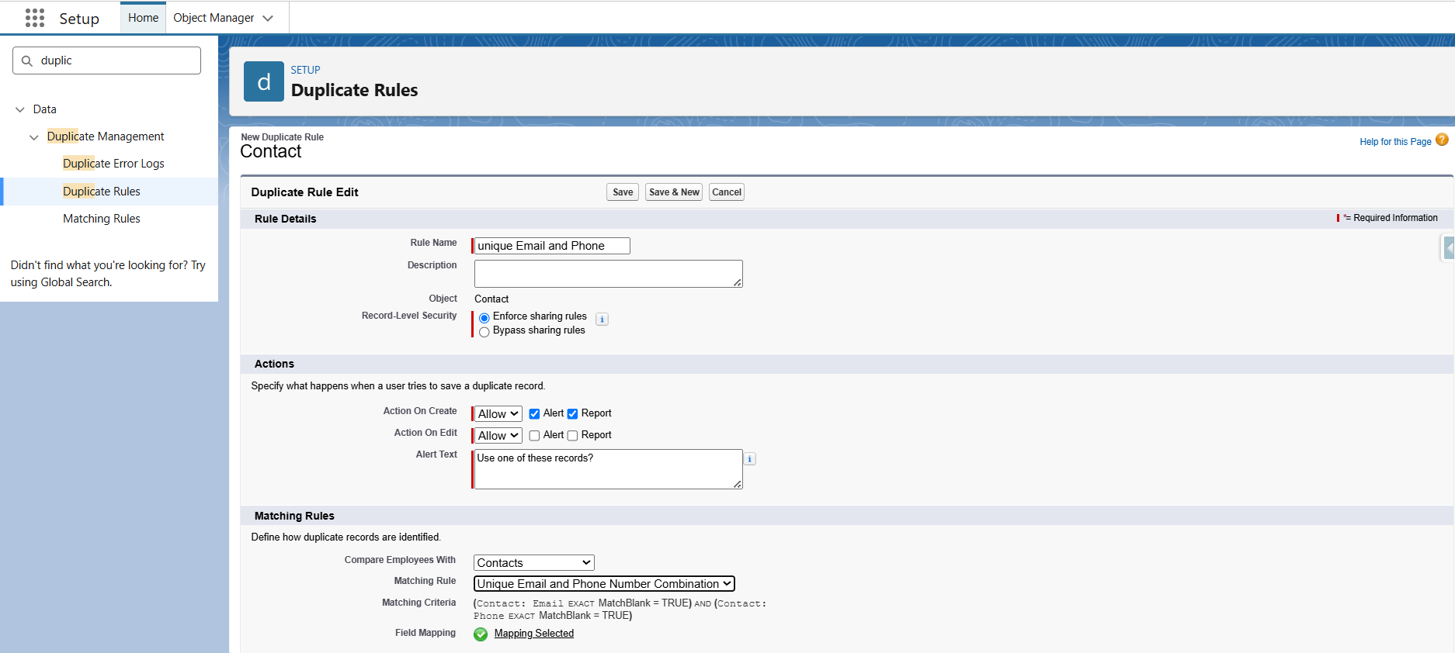

## **Milestone 16: Profiles**

A profile is a group/collection of settings and permissions that define what a user can do in salesforce. Profile controls “Object permissions, Field permissions, User permissions, Tab settings, App settings, Apex class access, Visualforce page access, Page layouts, Record Types, Login hours & Login IP ranges. You can define profiles by the user's job function. For example, System Administrator, Developer, Sales Representative.

**Types of profiles in salesforce**

1. **Standard profiles:**

By default, salesforce provides below standard profiles.

* Contract Manager
* Read Only
* Marketing User
* Solutions Manager
* Standard User
* System Administrator.

We cannot delete standard ones

Each of these standard ones includes a default set of permissions for all of the standard objects available on the platform.

1. **Custom Profiles:**

Custom ones defined by us.

They can be deleted if there are no users assigned with that particular one.

### **Activity 1: Employee Profile Creation**

**To create a new profile:**

* Go to **Setup** >> type **Profiles** in Quick Find box >> click **Profiles** >> clone the desired profile (**Standard User**) >> enter profile name: **Employee Profile** >> Save.
* While still on the profile page, click **Edit**.
* Select the **Custom App settings** as default for the **Hybrid Workforce Portal**.
* Scroll down to **Custom Object Permissions** and give **Read/Create/Edit/View All** access for the following objects:
* Work_Schedule__c
* Attendance_Log__c
* Wellbeing_Feedback__c
* Hybrid_Policy__c
* Announcements
* Task_Assignment__c
* Set **Session Timeout** to **2 hours of inactivity**.
* Configure **Password Policies** as:
* Passwords expire in **90 days**
* Minimum password length = **8**
* Click **Save**

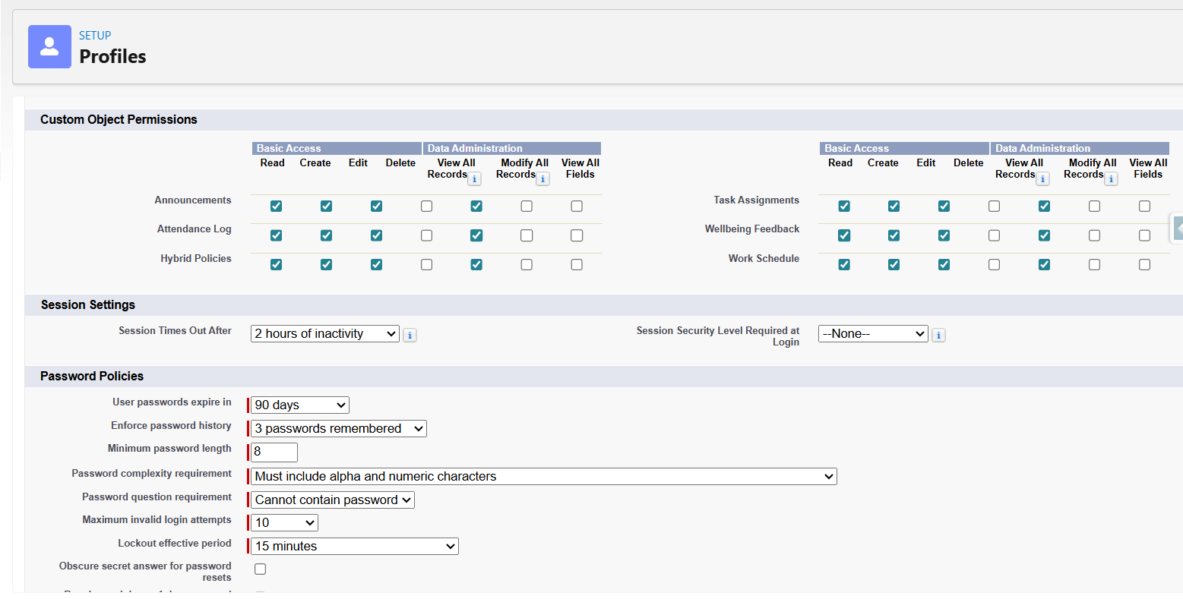

### **Activity 2: Manager Profile Creation**

1. Go to setup >> type profiles in quick find box >> click on profiles >> clone the desired profile (Standard User Profile) >> enter profile name (Manager Profile) >> Save.

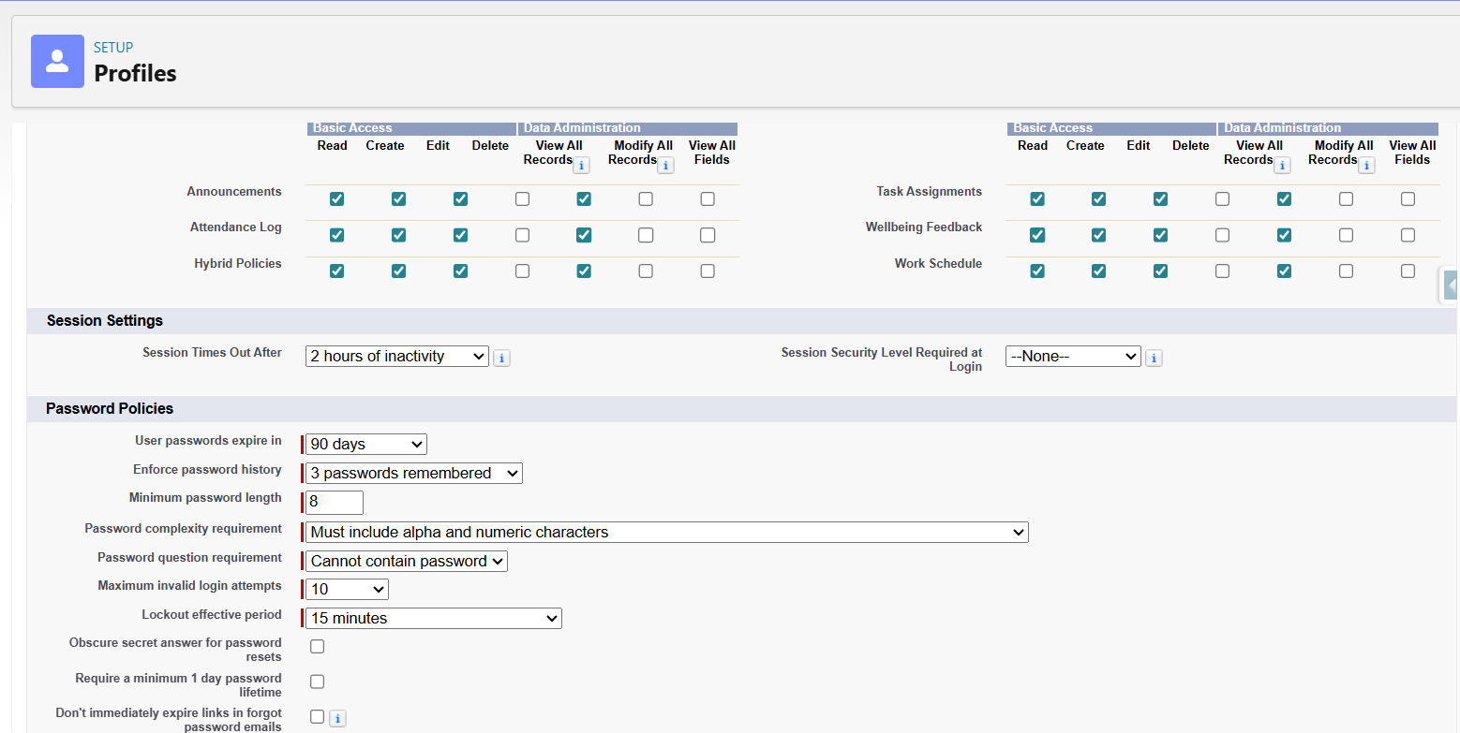

## **Milestone 17: Roles & Role Hierarchy**

A role in Salesforce defines a user's visibility access at the record level. Roles may be used to specify the types of access that people in your Salesforce organization can have to data. Simply put, it describes what a user could see within the Salesforce organization.

## 

### **Activity 1: Creation of Manager Role**

Creating Sales Manager Role:

1. Go to quick find >> Search for Roles >> click on set up roles.

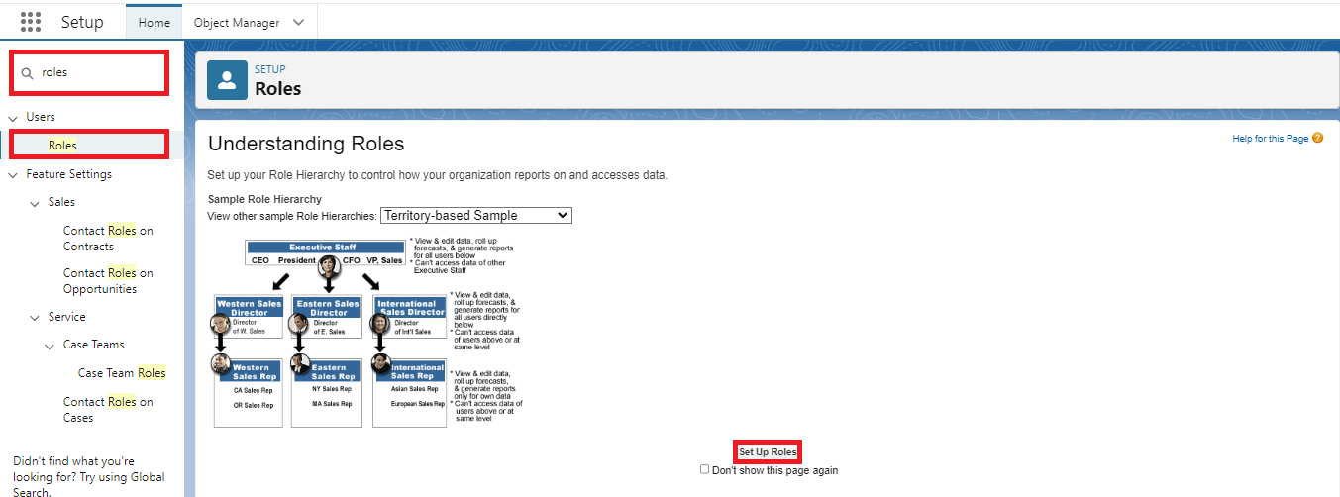

1. Click on Expand All and click on add role under CEO.

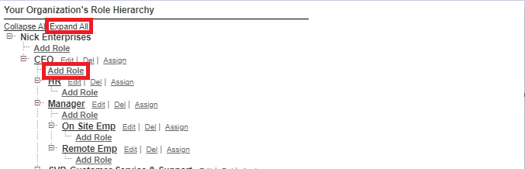

1. Give Label as “Hybrid Workforce Manager” and the Role name gets auto populated. Then click on Save.

### 

### **Activity 2: Creating Employee Role Under Manager Role**

Creating another two roles under CEO role

1. Go to quick find >> Search for Roles >> click on set up roles.
2. Click plus on Employee Portal Manager role, and click add role under Employee Portal Manager.
3. Give Label as “**Hybrid Workforce Employee**” and Role name gets auto populated. Then click on Save.

4. Create one more Role Under CEO.

5. Give Label as “**Hybrid Workforce Admin**” and Role name gets auto populated.

Then click on Save.

# **Phase 5: Deployment, Documentation & Maintenance**

## **Deployment**:

## In the scope of the Hybrid Workforce Portal project implementation:

## The complete portal, including custom objects, page layouts, Flows, and Lightning Application, has been built and configured within a Salesforce Developer Org.

## The primary goal of this phase is to understand how a Hybrid Workforce Management Portal can be developed, tested, and prepared for real-world deployment in an organization’s Salesforce environment.

## This includes configuring navigation items, access permissions, Lightning App, and deploying reusable pages for modules like:

## Work Schedules

## Attendance Logs

## Wellbeing Feedback

## Hybrid Policies

## Announcements

## Task Assignments

## Each page has been designed for easy usability and clear navigation to improve employee interaction and administrative efficiency.

## • Actual deployment (migration from development to production) is not performed in this project because:

## Developer Edition orgs are standalone and not connected to a production instance.

## Production deployment typically requires sandbox environments, change sets, or Salesforce DevOps tools (such as GitHub, Azure DevOps, or CI/CD pipelines) — which are part of enterprise-level projects.

## However, all objects, page layouts, Flows, and the Lightning App have been structured in a way that they can easily be packaged and deployed to production in the future using standard Salesforce deployment tools.

## **Maintenance, Monitoring & Troubleshooting**

## Maintenance ensures that employee schedules, attendance records, wellbeing feedback, and policy/task assignments remain accurate, secure, and up to date.

## Ongoing monitoring and maintenance include:

## Reviewing portal pages and Lightning App performance for responsiveness and accessibility.

## Ensuring security settings like profiles, permission sets, and sharing rules are updated according to employee role changes.

## Monitoring Flows for submission and approval processes for Work Schedules, Attendance Logs, and Task Assignments for any failures or delays.

## Maintaining duplicate rules and matching rules to prevent multiple entries for the same employee or overlapping attendance/feedback records.

## Updating Hybrid Policies and Announcements as per organizational changes.

## Tracking user feedback and implementing UI or automation improvements for a better employee experience.

## Although this project was implemented in a Salesforce Developer Org for demonstration and learning purposes, in a real-world enterprise deployment, these maintenance and monitoring activities are crucial to ensure the Hybrid Workforce Portal remains stable, scalable, and aligned with organizational policies and compliance.

## **Project Documentation:**

## Project documentation in the Hybrid Workforce Portal serves as a comprehensive record of the portal’s purpose, design, development, and deployment. It ensures that business requirements — such as managing employee schedules, attendance, wellbeing feedback, policies, announcements, and task assignments — are clearly defined and mapped to system functionality.

## Documentation benefits:

## Acts as a blueprint for developers and admins, guiding consistent development and enabling future scalability.

## Supports user training, troubleshooting, and maintenance by detailing every object, automation, and configuration involved.

## Assists in audit readiness, change management, and knowledge transfer, making it an essential asset for successful long-term sustainability.

## **Guidelines for Internal Employee Portal Documentation Submission**

## **General Instructions**

## Submit in professional format (Word or PDF).

## Use clear headings, subheadings, and bullet points.

## Maintain a consistent font (Times New Roman, size 12 or 13).

## Ensure zero grammatical or spelling mistakes and properly aligned sections.

## Plagiarism is strictly prohibited.

## **Mandatory Sections to Include**

## **Project Overview**

## The Hybrid Workforce Portal is a centralized Salesforce app designed to manage employees’ work schedules, attendance, wellbeing, company policies, announcements, and tasks. Employees can:

## View and manage their work schedules.

## Submit attendance logs and wellbeing feedback.

## Access Hybrid Policies and Announcements.

## Track assigned tasks. The portal improves internal communication, process automation, and reduces dependency on manual HR and operations management.

## **Objectives**

## Empower employees with **self-service capabilities** for scheduling, attendance, wellbeing, policy access, and task management.

## Reduce administrative overhead through automated **Flows and validation rules**.

## Ensure **secure, role-based access** for all employees.

## Improve employee engagement and productivity by centralizing organizational resources.

## **Phase 1: Requirement Analysis & Planning**

* **Understanding Business Requirements:**  
  Identify the need for a centralized platform for managing **work schedules, attendance, wellbeing, policies, announcements, and task assignments**.
* **Defining Project Scope and Objectives:**  
  Include modules:
  + Work Schedule
  + Attendance Log
  + Wellbeing Feedback
  + Hybrid Policy
  + Announcements
  + Task Assignment
* **Design Data Model and Security Model:**  
  Create necessary custom objects, define fields, establish relationships, and design record-level access based on employee roles

**Phase 2: Salesforce Development – Backend & Configurations**

* **Setup Environment & DevOps Workflow:**  
  Configure Developer Org and enable **Lightning App settings**.
* **Customization of Objects & Fields:**  
  Create objects for Work Schedule, Attendance Log, Wellbeing Feedback, Hybrid Policy, Announcements, and Task Assignment.  
  Configure validation rules to prevent invalid or duplicate entries.
* **Automation:**  
  Develop **Flows** for automated task assignment, attendance logging, policy acknowledgment, and schedule approvals.
* **Apex Classes / Triggers (if used):**  
  Optional backend logic for validations or record updates.

**Phase 3: UI/UX Development & Customization**

* **Lightning App Setup:**  
  Built **Hybrid Workforce Portal Lightning App** for centralized navigation.
* **Page Layouts:**  
  Customized layouts for all objects for better data entry and visibility.
* **Navigation Items:**  
  Added pages for:
* Work Schedule
* Attendance Logs
* Wellbeing Feedback
* Hybrid Policies
* Announcements
* Task Assignment
* **User Management:**  
  Created profiles, roles, and permission sets to control access.

## **Phase 4: Data Migration, Testing & Security**

## **Data Migration:** Used Data Import Wizard to load employee records, schedules, attendance logs, tasks, and policies.

## **Field History Tracking:** Enabled for key fields to track updates and approvals.

## **Duplicate & Matching Rules:** Configured to prevent overlapping attendance or duplicate task assignments.

## **Profiles, Roles, and Permission Sets:** Defined access levels for Employees and Managers using role hierarchy and sharing rules.

## **Testing: Conducted:**

## Unit Testing for Flows and backend logic.

## UAT to ensure data accuracy and workflow correctness.

## Security testing for profile-based and object-level access.

## **Phase 5: Deployment, Documentation & Maintenance**

## **Deployment:** The portal was built in a Salesforce Developer Org to simulate real-world deployment. Actual production deployment was not performed due to Developer Org limitations, but the architecture supports migration via Change Sets or Salesforce DevOps tools in the future.

## **Maintenance, Monitoring & Troubleshooting:**

## Regularly review page layouts, Flows, and app performance.

## Monitor attendance, schedules, wellbeing feedback, tasks, and policy updates for accuracy.

## Maintain security via profiles, permission sets, and sharing rules.

## Update company policies, announcements, and workflows as needed.

## Resolve errors via **debug logs** and update Flows/validations for new business rules.

**Project Documentation:**  
Documentation ensures all objects, workflows, profiles, roles, and validations are recorded. It guides:

* Future maintenance
* User training
* Audit compliance
* Change management

**Conclusion**

The Hybrid Workforce Portal project demonstrates how Salesforce can be leveraged to enhance internal operations and employee engagement in a hybrid work environment.

Through a combination of custom objects, Flows, page layouts, and secure user configurations, the system enables seamless management of work schedules, attendance logs, wellbeing feedback, hybrid policies, announcements, and task assignments while providing employees with direct access to organizational resources.

Although developed within a Salesforce Developer Org for training and demonstration purposes, the project reflects real-world workforce process automation practices. It highlights the importance of UI design, security setup, automation, and ongoing maintenance to build a scalable and user-friendly portal.

## **Guidelines for Internal Employee Portal Project Demo Video Presentation**

## The Project Demo Video showcases the complete working of your portal — both UI and backend — demonstrating your technical, presentation, and problem-solving skills.

## The Project Demo Video showcases the complete working of your portal — demonstrating both UI and backend functionality — and highlights your technical, presentation, and problem-solving skills.

## **Steps for Demo Video Presentation**

## **Introduction**

## Introduce yourself and your project name: “Hybrid Workforce Portal using Salesforce.”

## Briefly explain the project’s purpose (managing schedules, attendance, wellbeing, policies, announcements, and task assignments).

## **App Overview**

## Show the Lightning App from the App Launcher.

## Mention custom objects like Work_Schedule__c, Attendance_Log__c, Wellbeing_Feedback__c, Hybrid_Policy__c, Announcements, and Task_Assignment__c.

## **User Interface Demonstration**

## Demonstrate:

## How employees access the portal.

## Submitting attendance logs, wellbeing feedback, or task updates.

## Viewing Hybrid Policies and Announcements.

## The Lightning App navigation and page layouts for all objects.

## **Business Process Automation**

## Show the Flows created for automated task assignment, attendance approvals, or wellbeing feedback submissions.

## Explain any notifications or email automation if configured.

## Open related backend logic (Apex Classes or Triggers if any) to show automation handling.

## **User Management & Security**

## Demonstrate Profile and Permission Set configuration for portal users.

## Show role hierarchy, sharing rules, and field-level security ensuring restricted access to sensitive data.

## **Error Handling & Debugging**

## Briefly show debug logs or Flow error handling setup.

## **Highlights**

## Showcase the Lightning App, page layouts, navigation structure, and personalized UI for the Hybrid Workforce Portal.

## Mention unique features like role-based access for employees and managers.

## **Conclusion**

## Summarize the complete portal workflow and its business value.

## Mention that it was tested, documented, and is ready for production adaptation.

## **Pro Tips for Project Demo Video** Use your own voice for explanation. Keep the video 5–10 minutes long and structured. Record in HD (720p or above) using Loom, OBS, or Zoom. Avoid background noise and unnecessary pauses. Demonstrate real data — submit leave and asset requests during the video. End confidently summarizing your contribution and the project’s benefits.

## **Conclusion**

## The Hybrid Workforce Portal successfully illustrates how Salesforce can streamline hybrid workforce operations.

## With features like work schedule management, attendance logging, wellbeing feedback, task assignments, and centralized policies and announcements, the system boosts transparency, efficiency, and employee engagement.

## Even though implemented in a Developer Org for practice purposes, it aligns with real-world Salesforce project standards, demonstrating end-to-end understanding of object design, automation, security, and deployment readiness.